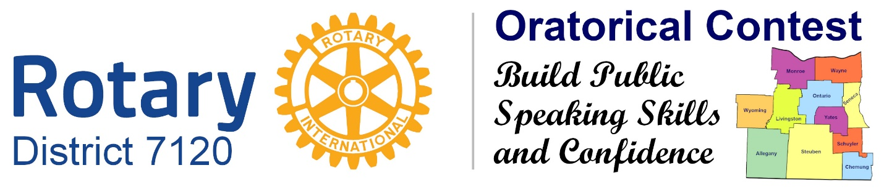
Rotary District 7120 Oratorical Speech Contest
Scholarships Information
Listed below are the Area Colleges participating in the Rotary Oratorical Contest by offering scholarships. Each of the participating institutions has offered one scholarship per year, with the exception of Elmira College, which offers up to three. Scholarships are not transferable from one institution to another. Those qualifying for these prizes in the Oratorical Contest must apply for and be accepted to the institution of their choice independent of the Oratorical Contest. Winning the contest does not guarantee admission. Scholarships are only a partial payment of total college expenses.
In every case, students must also file the Free Application for Federal Student Aid by the deadline for that application, must enter studies as a full-time student (typically, 12+ semester hours per semester) during the Fall term following High School graduation, and must present documentation from the Oratorical Contest Chair to the College of their choice with their financial aid application.
The names of contest winners and scholarships they have chosen must be communicated to the institutions in question by January 31, for studies commencing during the Fall Term of the same year. The first-place winner must inform our contest chair, Donald Collins (4931 Butler Road, Canandaigua NY 14424), in writing, of his or her selection by Dec 10. The second-place winner will be notified by Dec 10 which scholarship had been reserved, and will have until Dec 20, to select and inform the contest Chair of his or her selection of the remaining scholarships. Following this pattern, the third-place winner would have until Jan 5, the next year, fourth place will have until Jan 15, the next year, and fifth place will have until Jan 25, next year.
Typically, the total of all scholarships a student receives cannot exceed the value of full tuition. Additionally, scholarship awards at most schools cannot be added together: the school awards the student the most lucrative scholarship for which he or she qualifies. Several colleges have specific entrance and continuance requirements (see below).
To maintain the scholarship beyond the first award, the student must continue to maintain a high level of academic achievement. The specific institutional requirements in this regard are listed below. Additionally, each institution requires the annual filing of the FAFSA form by the filing deadline.
Scholarships Available
Alfred University, $2,500 per year for four years, $10,000 value
Elmira College, $10,000 per year for four years, $40,000 value
Finger Lakes Community College, $500 per term for four terms (two years), $2,000 value
Keuka College, $2,500 per year for four years, $10,000 value
Monroe Community College, $750 per term for four terms (two years), $3,000 value
Nazareth College, $3,000 per year for four years, $12,000 value
Roberts Wesleyan College, $2,500 per year for four years, $10,000 value
Rochester Institute of Technology, $5,000 per year for four years, $20,000 value
St. John Fisher College, $2,500 per year for four years, $10,000 value
SUNY Geneseo, $750 per year for four years, $3,000 value
The College at Brockport, SUNY, $750 per year for four years, $3,000 value
The University of Rochester, $10,000 per year for four years, $40,000 value
Cash Award, $10,000 – must show proof of enrollment to qualify
(May be subject to taxation)

Information Unique to Individual Institutions:
In Addition to the Common Requirements Listed Above
Keuka College: Renewable annually if student maintains a 3.25 cumulative grade point average.
Elmira College: Three scholarships available, renewable annually if student maintains a 2.5 cumulative grade point average.
Finger Lakes Community College: Student must maintain a 3.00 grade point average to qualify for each disbursement.
Monroe Community College: Renewable each term if student maintains a 3.00 cumulative grade point average.
Roberts Wesleyan College: Renewable annually if student maintains a 3.25 cumulative grade point average.
Rochester Institute of Technology: Eligibility: Freshman Applicants with SAT 1800* or higher (ACT 26); strong extracurricular achievements (such as winning this contest);
B+ Average in High School studies.
Renewable each year if the candidate maintains a 2.80 cumulative Grade Point Average at RIT.
May not be combined with other RIT merit scholarships.
Candidate must apply for admission to RIT by February 1, and qualify for admission independently of the Rotary Oratorical Contest process.
St. John Fisher College: Competitive entrance requirements:
Student must attend full-time (12+ credit hours per semester).
Renewable annually if student maintains a 3.0 cumulative grade point average.
Cannot be combined with any other 'special' scholarship programs.
SUNY Geneseo: Competitive entrance requirements:
Student must attend full-time (12+ credit hours per semester).
Renewable annually if student maintains a 3.0 cumulative grade point average.
The College at Brockport (SUNY): Eligibility: Freshman Applicants with SAT 1400* or higher, High School average of 90 or higher, ranked in top 25 percent of High School class.
Renewable if student maintains a 3.0 cumulative grade point average.
Candidate must apply for admission to The College at Brockport by March 1.
The University of Rochester: Competitive entrance requirements:
The University of Rochester does not combine scholarships. If the student qualified for an award in a greater amount than the Rotary Oratorical Scholarship, the student will be recognized as an ROS award winner, but may receive a separate and more valuable scholarship. University of Rochester employees and their spouses/partners or children eligible for tuition benefits are not eligible to receive the full value of the award.
*With the recent changes in SAT scoring, the institution at any time may revise these figures.
Revised 9/5/2012 & 11/22/16 & 11/8/2017 & 10/4/19 & 5/14/2022 & 10/30/2022

