District Literacy Seminar at Clifton Springs Hospital  INTERNATIONAL LITERACY GOALS  EVERY CLUB A LITERACY PROJECT  EVERY DISTRICT A LITERACY SEMINAR  EVERY CONFERENCE A LITERACY SESSION  EVERY GOVERNOR A LITERACY AWARD  OBSERVE INTERNATIONAL LITERACY DAY  EVERY CLUB SEEK OPPOURTUNITIES…  …IN THEIR COMMUNITY FOR LITERACY |  |  | Who We Are…  Rotary District 7120 Literacy Committee  VISION STATEMENT  The District 7120 Literacy Committee will Be a source of ideas and Inspiration and a resource for materials designed to help clubs address literacy needs in their communities  Contact Us:  7120 District Chair Pam Dean  Mesunshine1@msn.com  Web: www.  Governor Mike  DISTRICT 7120  Rochester, N.Y. |  |  | COMMITTEE MEMBERS  Pam Dean (Chair) mesunshine1@msn.com  Maryann Mady mamady@rochester.rr.com  Tracy Wooden tmw042@gmail.com  Ellen Hughes ellenhughes13-14@rochester.rr.com  Mary Merritt rmerrit1@rochester.rr.com  JoAnn Terry jotee218@aol.com  Ann Demers ann_demers@hotmail.com  Debbie Hughes deblung@hotmail.com  Linda Ann Goodrum lindagoodrum@gmail.com  Nancy Aumann naumann@rochester.rr.com  Scott MacDonell smacdone@rochester.rr.com  Ruth Cronkwright rconkwright@rochester.rr.com  Bill Dean pastpres2004_5@msn.com

Literacy is COOL & So Is  READING |  |  | THIS IS WHAT  WE DO…  _________________________________________________  2002-2003 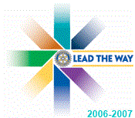 |  |  | 2018-2019  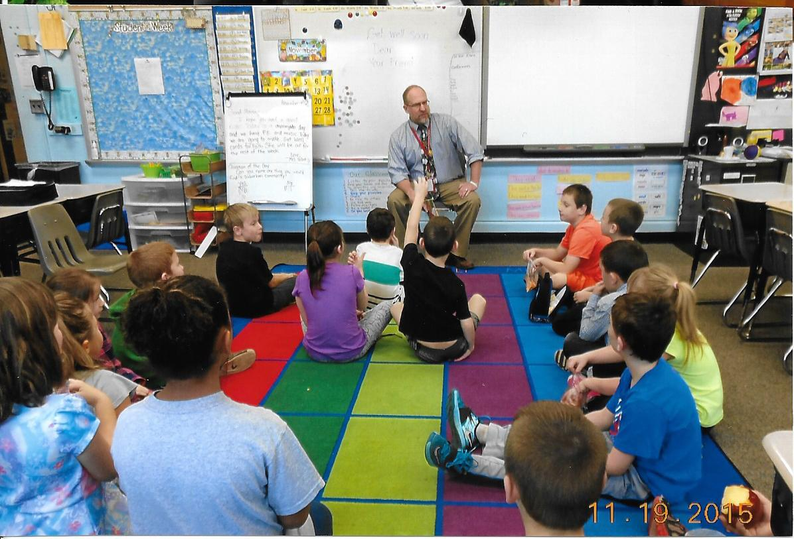  “Apple Dumpling” with Brian Brooks  The Four Way Test Explained  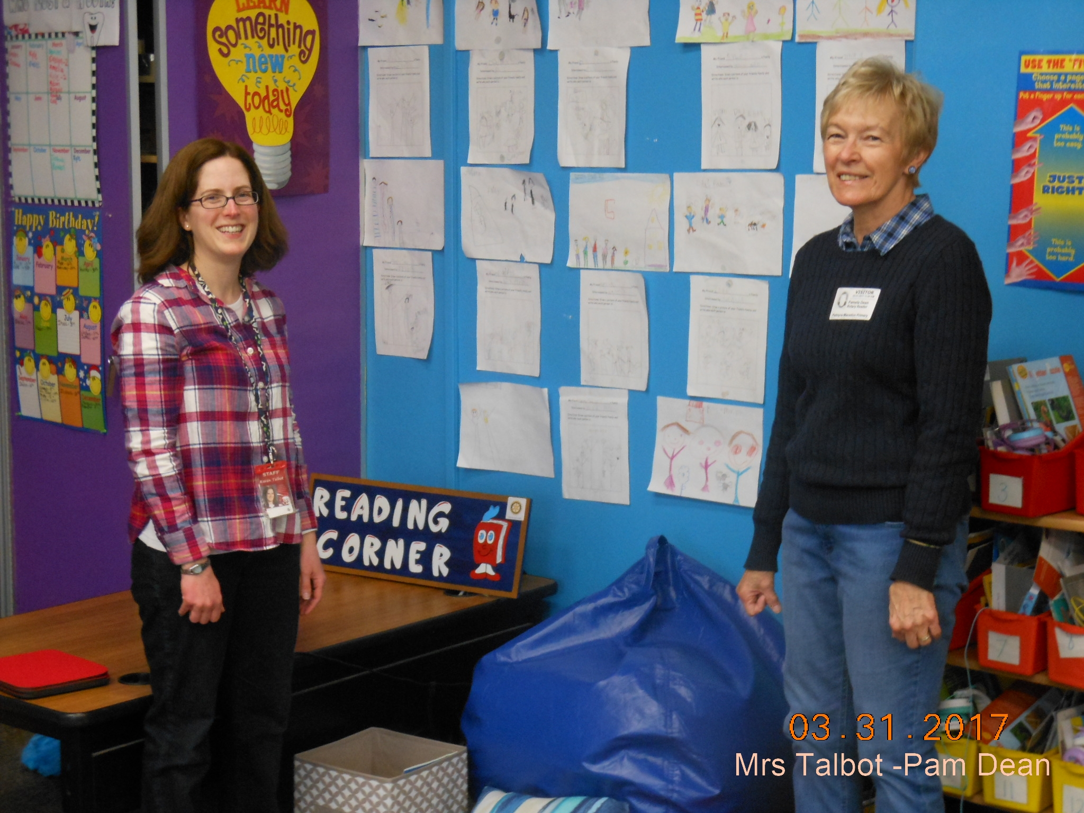  Teacher Mrs. Talbot & Pam Dean  In a Reading Room at Pal-Mac

