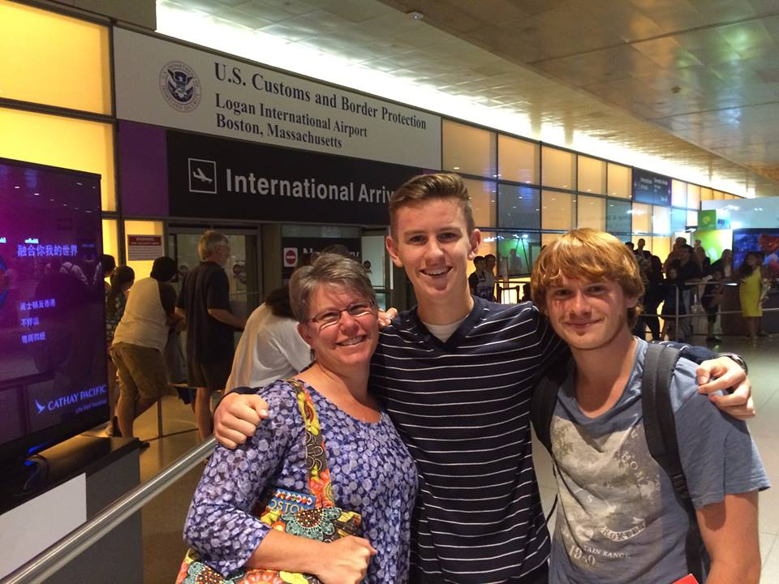  What’s so great about STEP?  It’s affordable: Students and their families pay travel expenses and modest fees for administration and insurance.  It’s simple: Local Rotarians promote the program and help students and their families apply. Rotary’s Eastern States Student Exchange (ESSEX) arranges the matches, and the families make their own travel arrangements.  It’s for everyone: Anyone aged 15 to 18⅟2 is eligible.  It’s flexible: There is no set schedule for travel. Families decide everything for themselves.  It’s powerful: These summer exchanges are life-changing. | Rotary Short-Term Exchange (STEP)  A Step in the Right Direction  This low-cost program changes lives by enabling high school students to live with host families abroad and host their overseas “match” here in Maine.  This brief exposure to another culture has tremendous impact. Participants discover a wider world and often end up studying abroad in future years. Some go on to pursue international careers.  Kathi Perkins, 207-253-1778 kperkins1@myfairpoint.net or  Dick Hall, 207-749-9186 dickhall@maine.rr.com  Web: www.exchangestudent.org | “I’m going to Tanzania to design and build a sunflower oil factory for a growing village. STEP helped me believe these kinds of things were possible for a kid from rural Maine.” Park: France
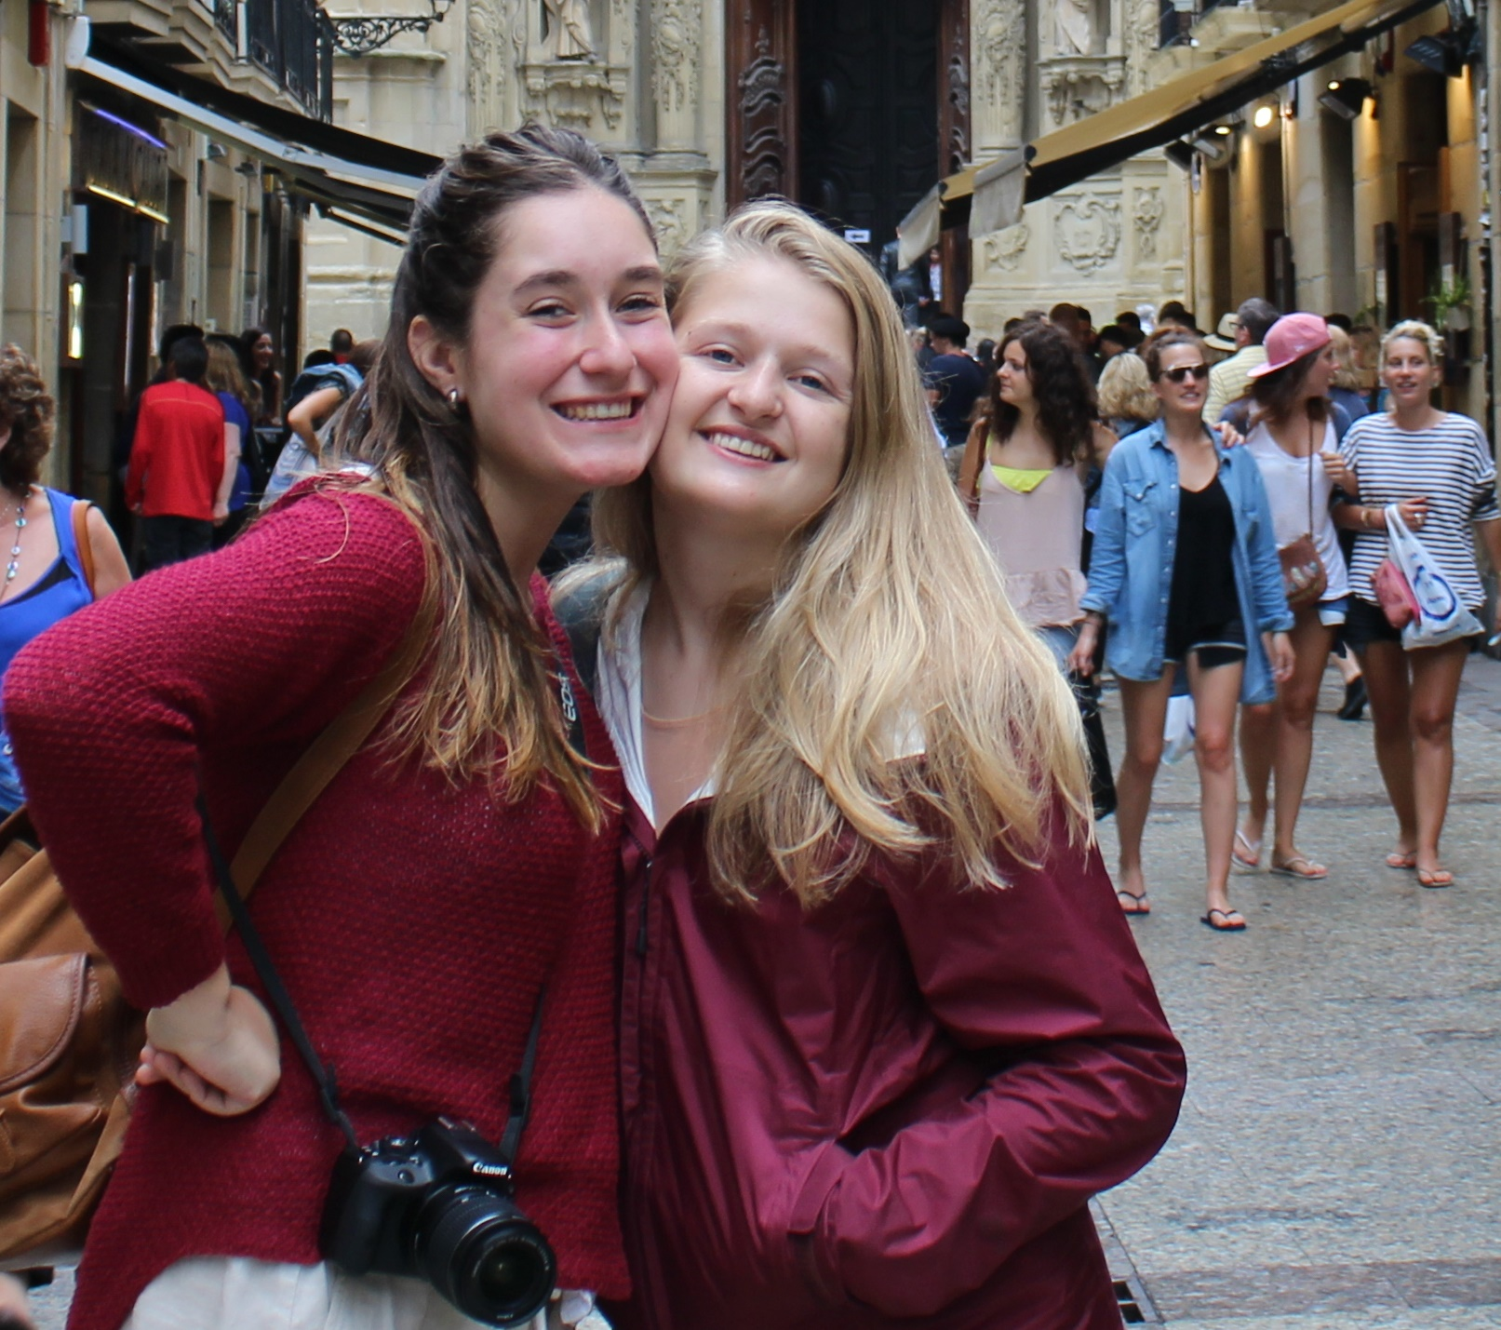  Get involved:  Visit www.exchangestudent.org to learn more about short-term exchange  - Create a committee of two or three people to promote the program and help students apply  - Assign a club member to serve as a counsellor for each student visiting from abroad – a local contact the student can call on if they need advice of any kind | “Without STEP, I wouldn’t have discovered my passion for travel and experiencing new cultures.” Carman: Italy  “I am serving with AmeriCorps in Puerto Rico. I doubt that I would have believed in myself enough to do this if it wasn’t for my experience with the Rotary STEP exchange.” Sawyer: France | 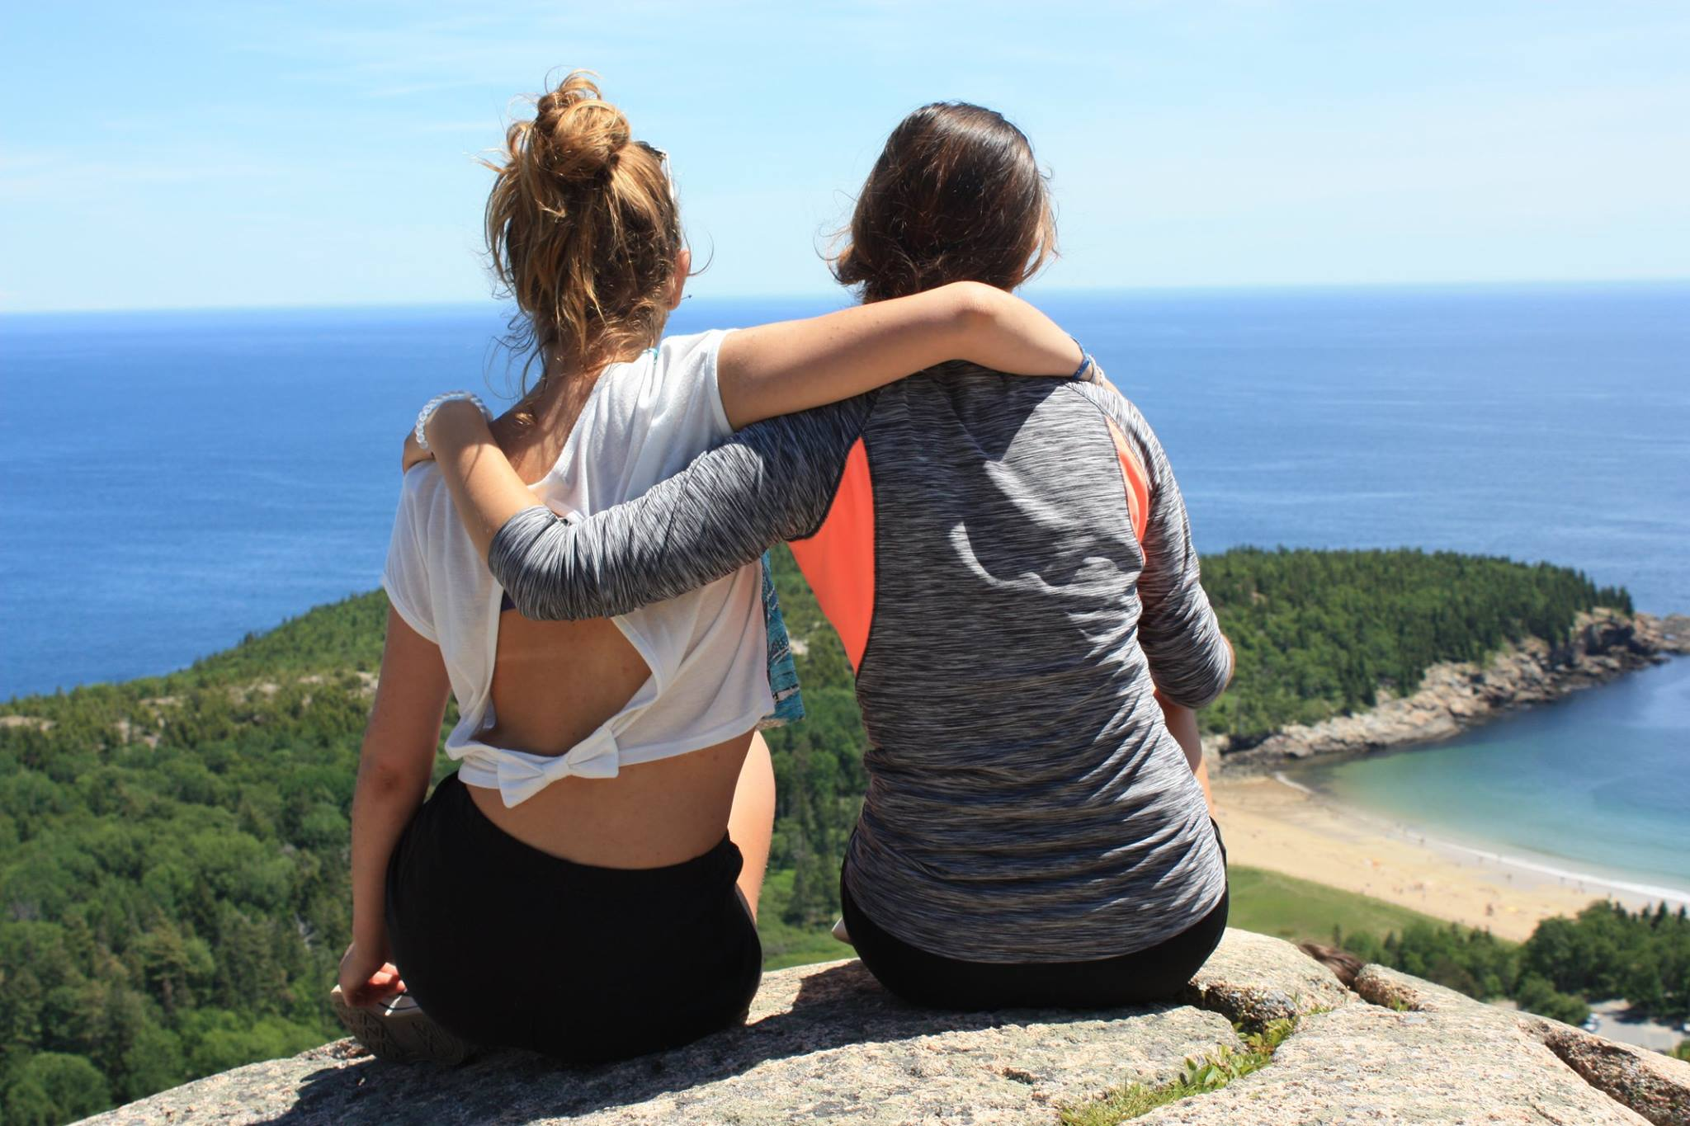  STEP’s long history  A long history  - In 1927 the Rotary Clubs in Copenhagen, Denmark began arranging two-week exchanges during school holidays  - The Rotary Club of Nice, France, followed suit in 1929.  - Today, short-term exchange students have 28 countries to choose from for their summer adventures.

