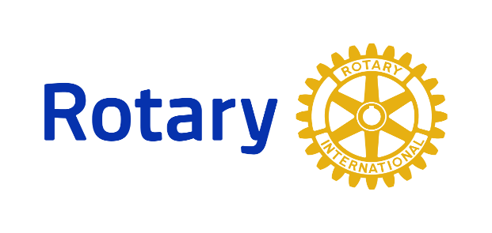

District 7255 Interact
___________________________________________________________________

What is an Interact Club? Interact clubs bring together young people ages 12-18 to develop leadership skills while discovering the power of Service Above Self. Interact Clubs organize at least two projects every year, one that helps their school or community and one that promotes international understanding. Rotary Club sponsors, mentors and guides Interactors as they carry out projects and develop leadership skills.
For more info on starting or joining an Interact Club:
Contact Rotary District 7255 Interact Chair warrensternberg1@gmail.com

