Contributions to THE ROTARY FOUNDATION
Australia
- Website
Rotary’s preferred way of receiving contributions is via rotary.org/donate.
Australians should specify AUD as the currency, in order to receive a tax-deductible receipt.
Website transactions are by credit card, so may not be suitable for some Rotary Clubs.
- Electronic Funds Transfer
Non-tax-deductible donations from clubs & districts, as well as contributions to the Endowment Fund, should be paid into the TRF Account:
St. George Bank
Acct Name: The Rotary Foundation
Acct No: 100345225
BSB No: 332 084
Reference: Club number + club name (without “Rotary Club of”) eg: “18010CastleHill”.
Tax-deductible donations from (or on behalf of) individuals and businesses (and from tax-registered clubs) should be paid into the TARFT Account:
St. George Bank
Acct Name: The Australian Rotary Foundation Trust
Acct No: 551038195
BSB No: 332 084
Reference: Donor name + ID number
For multiple donors: M + club number + club name and email the list of donors.
Contributions to TARFT will generate a TAX RECEIPT for Australian tax deductibility.
When paying by EFT, please send a copy of the bank receipt and/or TRF Contribution Form.
When we don’t receive this information and have to run a trace, it is time-consuming and expensive.
Always copy RISPPO, even when you have already sent an email to your District / Club Officer.
Emails should be sent to risppo@rotary.org – for enquiries, call +61 2 8894 9800.
- Credit Card
Credit card contributions can be:
- phoned through to the RISPPO Office (+61 2 8894 9800)
- mailed to the RISPPO Office using the Contribution Form (PO Box 1415, Parramatta, NSW, 2124).
For security reasons, credit card payments should NOT be emailed.
- Cheque
Cheques should be mailed to the RISPPO Office using the Contribution Form
(PO Box 1415, Parramatta, NSW, 2124).
For all payment methods, don’t forget to let us know to which fund the donation should be directed – Polio Fund, Annual Fund, Endowment Fund, etc.

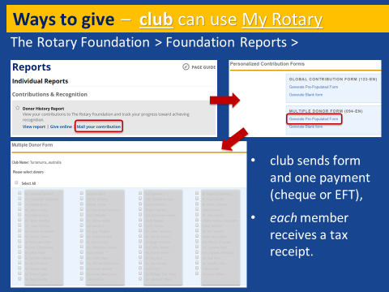 | 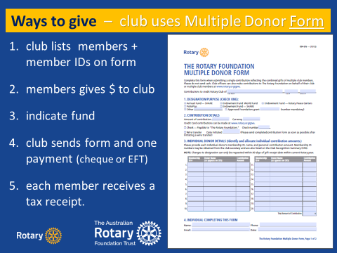
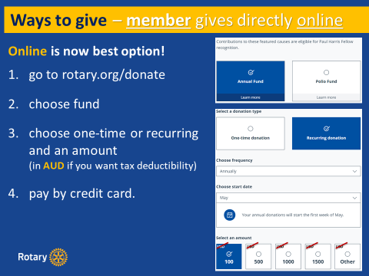 | 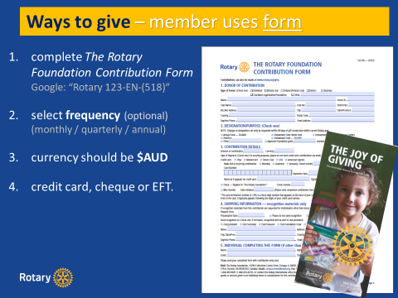

PHF Medallion
The purchase of Paul Harris Fellow Medallions can only be handled through the Rotary Shop – cost US$15.00. Go to:
https://shop.rotary.org/paul-harris-fellow-medallion
While these online orders go to Rotary International, fulfillment is handled by the South Pacific and Philippines Office in Parramatta.

