**Health of the River Forum 2018**

The HOTR Forum has again become another of the special Rotary funded opportunities for students of Districts 9500 and 9520.

During 5th – 8th of November 16 Yr. 9 and 10 students from across the two districts travelled to Calperum Station, near Renmark, SA and took part in 4 days of environment based ecological studies.

The Forum was run by the education and research team based at Calperum and was ably supported by five Rotarians who took part in the many activities held at the site.

Students undertook studies in Tree Health, Pitfall Trapping, Soil and Salinity management and a Cultural History Study of local river use; including indigenous habitation.

The students were engaged in species collecting, record keeping, soil management, tree health assessments, fauna identification, erosion control, group collaboration, recording and graphing of results, reporting as a team, and a host of other social activities; including a “Calperum’s Got Talent Show” and Quiz Night.

All who took part, were impressed with the educational programme offered, the excellent catering and fun filled activities. Preparation for HOTR 2019 has commenced and a tentative date of 21st – 25th of October 2019 has been set.

We very much hope the Forum can be an even bigger and better success next year and hope more students across our districts take part.

See below some photos taken and a few excerpts from the student feedback received and we hope to make your club keen to sponsor students when applications are called for next year!

**Bruce Cole and Dick Cuttle (HOTR 2018 Convenors)**

Indigenous and Cultural Study

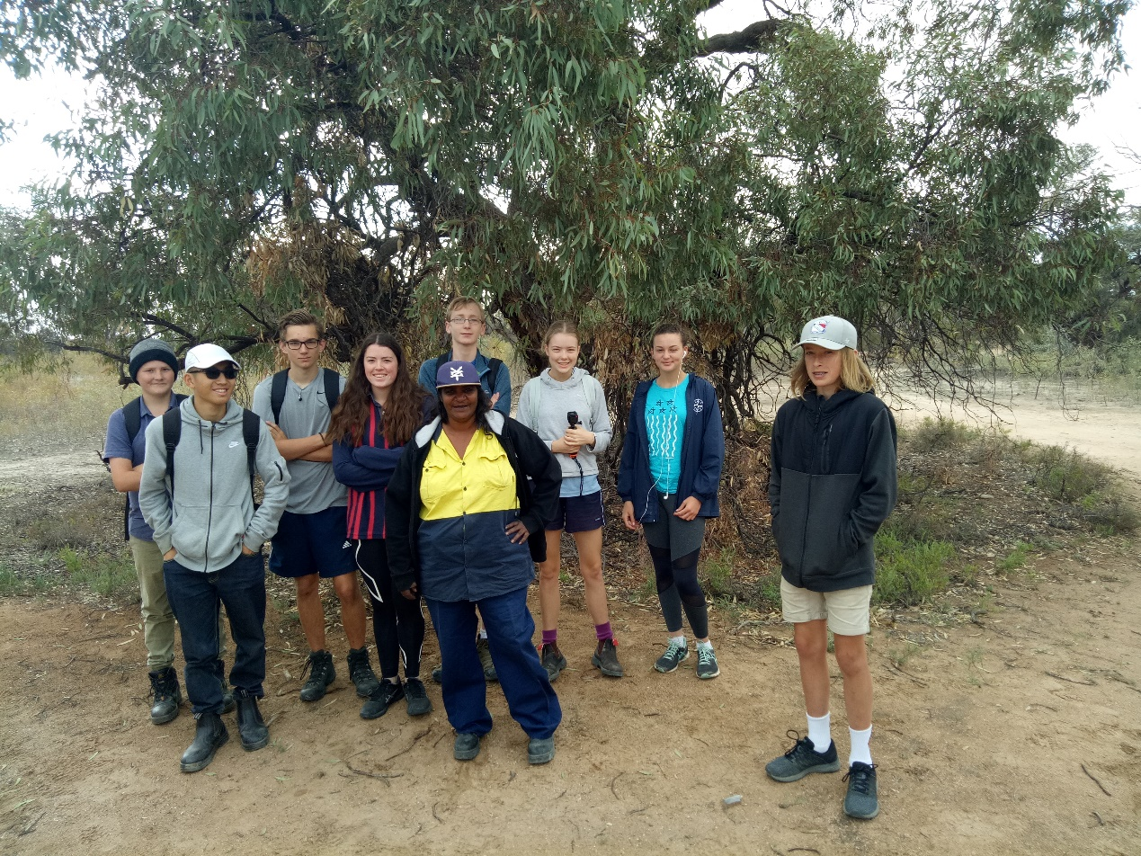

Tree Health Study

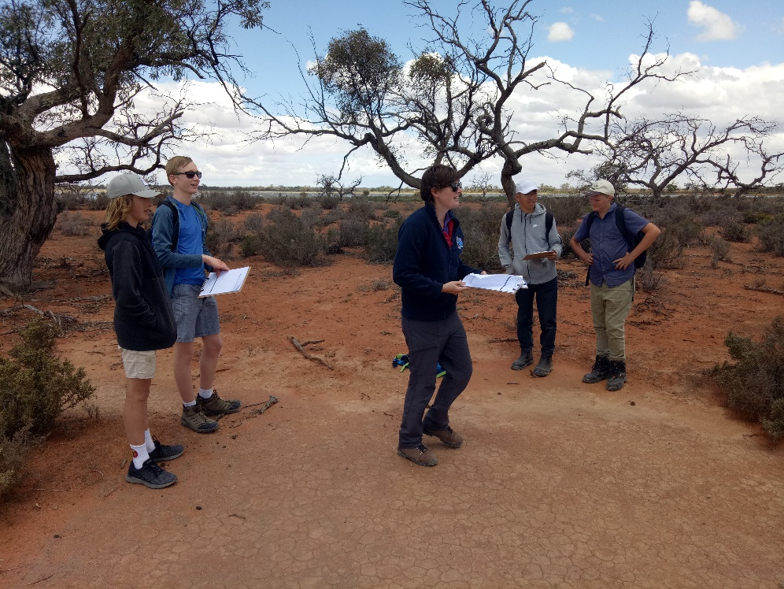

Erosion and Habitat Rehabilitation Study

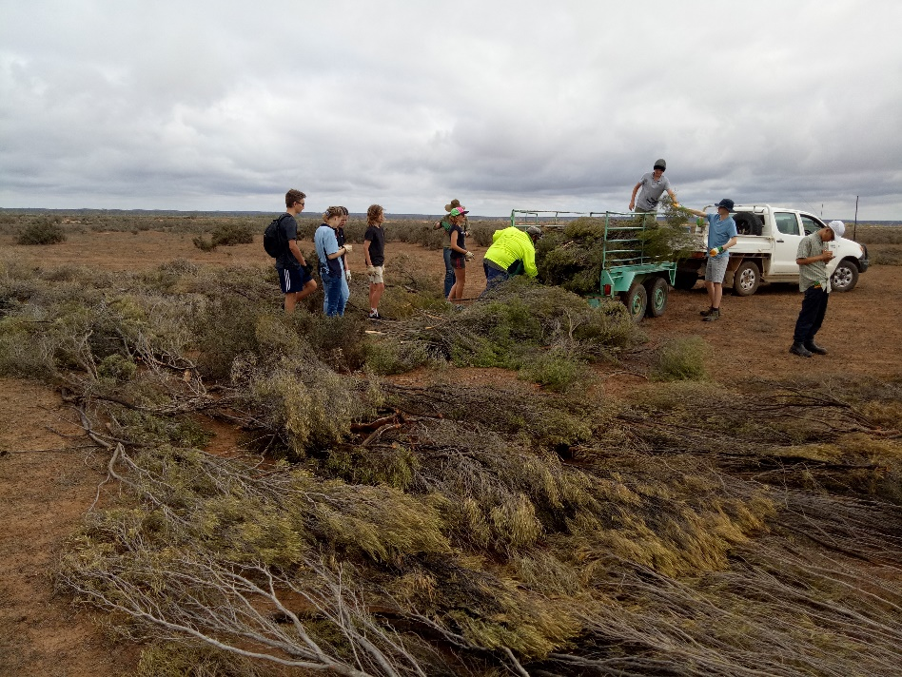

Pitfall Trapping Specimen



Reporting on Findings

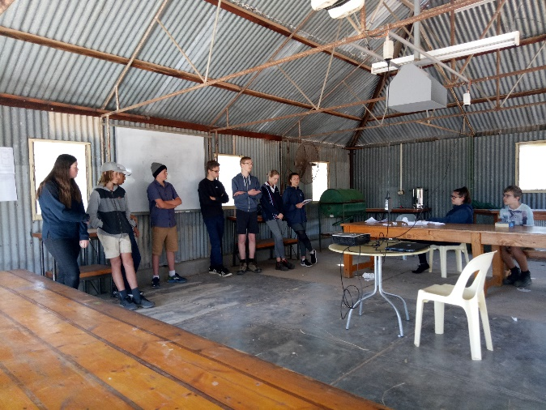

HOTR 2018 Students

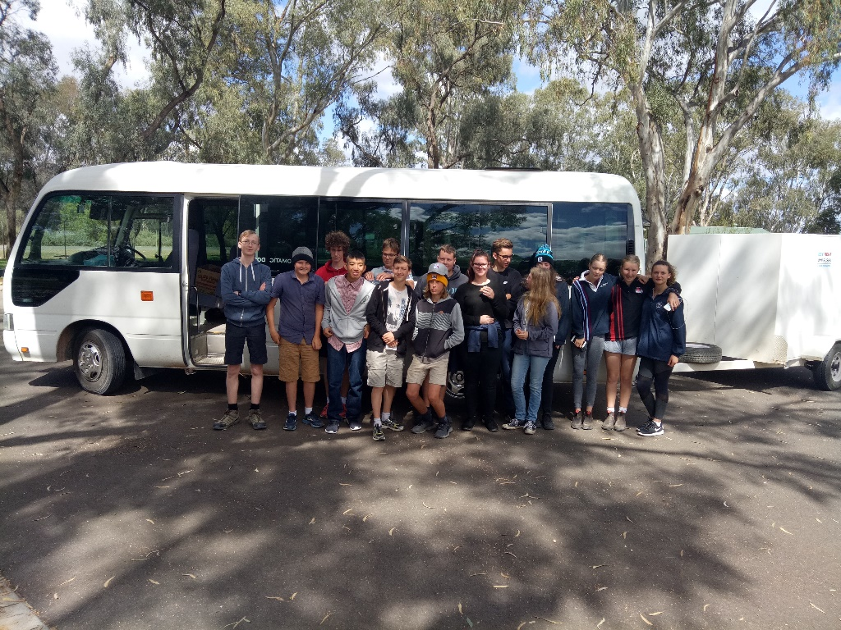

Student Feedback – Just a few excerpts from the 16 who took part.

Faith – *(HOTR) “teaches you really cool facts!”* Guthrow – *“For anyone interested in this area of the environment, I would strongly recommend it!”* Liam – *“It is a fun experience for young people!”* Grace – *“It was a great learning experience and opportunity.”*  Hayate *– “I believe I learnt more than what I usually learn in my science class as you were able to observe the experiments in large scale.”* Emily *– “It was good to look further into the real life of ecology and biology. This has given me more of a path for my future.”* Dana *– “I think that every student should get the opportunity to come!”* Rachelle *– It was a fun and enjoyable trip which I would do again!”*