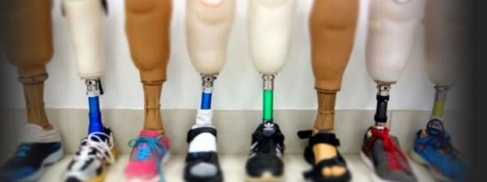
Developing Rehabilitation Departments in the Western Pacific

The Rotary Club of Torquay and Motivation Australia have been working together for 18 months on a project to advance orthotic and prosthetic services in our adjoining Pacific neighbours. The project, financed by a $50,000 (AUD) Global Grant, will enable the first of three teams of volunteers to conduct an initial workshop in Tonga in April 2020. With a further two workshops to follow later in the year.
Motivation Australia (MA) has been working with staff in Pacific Island hospitals “rehabilitation” departments for the last 13 years, supporting them to become appropriate and sustainable providers of a wide range of rehabilitation and assistive technology services.
Over this time Motivation Australia has supported many different nations including Fiji, Kiribati, Papua New Guinea, Samoa, Solomon Islands, the Cook Islands, the Marshall Islands, Tonga and Vanuatu.
In April 2019 MA convened a conference in Fiji to explore the most pressing needs of these Pacific Island nations. Service providers, disabled persons organisations, and users of rehabilitation or mobility device services, development partners and donors from each of these countries, and from Australia and the US were invited to participate in the conference.
Representatives from Pacific Island organisations and service providers presented on their strengths, success stories and areas of focus in the coming years.
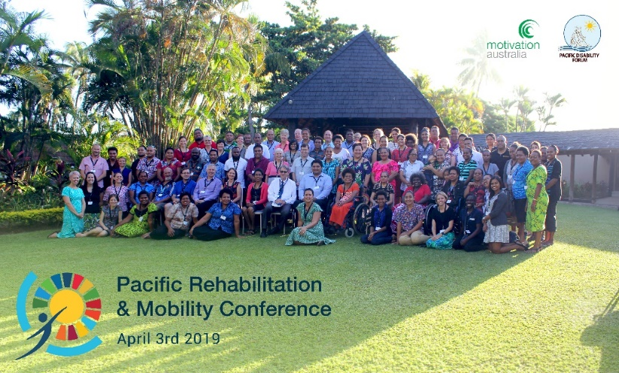
The Rotary Club of Torquay sent two representatives, Past President Gaynor Schols and Rotarian Ben Featherston, along to this conference to develop a community needs analysis in order to be able to initiate a Global Grant application from the Rotary Foundation.
Essentially, service providers requested a program of Continuous Professional Development (CPD) to support and expand the skills, knowledge and confidence of their teams. Through their presence and commitment to the Pacific Islands Motivation Australia was already providing a newfound hope.
Following the conference Motivation Australia and the Rotary Club of Torquay decided to partner and apply for a series of Global Grants to deliver Continuous Professional Development programs to each of these nations. The Rotary Foundation has awarded a Global Grant for our first program -a series of Volunteer Training Teams to the Vaiola hospital in Tonga - subject to a contingency clause (to furnish the names/details of professionals on the team, and to provision of a detailed training plan). Motivation Australia is currently advertising for volunteer professionals. We expect to start delivering the first pilot program in April of this year and then follow with additional Global Grants for the remaining nations in need.
John Oswald (International Service Committee, The Rotary Club of Torquay)
Robyn O’Loughlin (Chair, International Service Committee, The Rotary Club of Torquay).

