ROTARY CLUB OF TORQUAY ANNUAL REPORT
1 JULY 2017-30 JUNE 2018
PART A

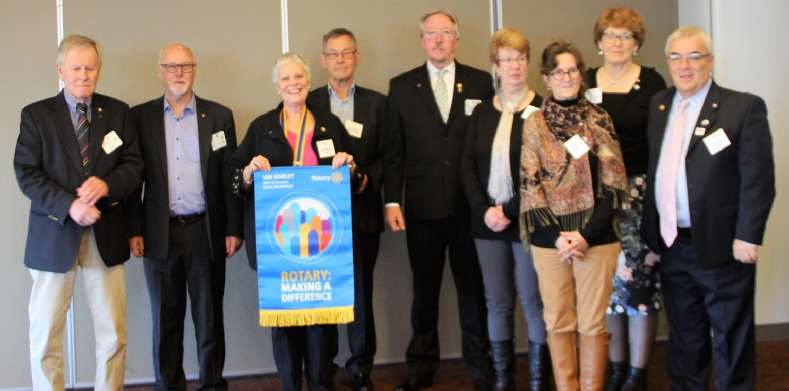
FROM THE PEN OF PRESIDENT GAYNOR SCHOLS  We have certainly achieved our theme this year “Rotary: Making a Difference”.  We started the year by raising over $8000 from the “Dine with Cadel Evans” event for health projects, the Book Fair in January raised over $6000, Night Jar Parking brought in over $4000 and the BBQ program gave us over $13,000 but our record Motor Show was clearly the winner with a profit of $21,273. Other funds came from marshalling at the Cadel Evans Great Ocean Road Race, Ride the Bellarine, ANZAC Day and Entertainment Books.  We spent over $65,000 this year. The shed was the largest expense at around $16,000 but most of this came out of savings. Community projects cost over $23,000 and included donations to the RSL, Jan Juc Surf Lifesaving Club, Food Aid, the District 9780 Bush Fire Appeal, Barwon Health Car, Relay for Life, Foundations for Prostate Cancer, Parkinsons, Peace of Mind and Cystic Fibrosis, Australian Rotary Health, Lifeline, Scouts, Torquay Fire Brigade, Very Special Kids and End Trachoma 2020. |  |  | CLUB HIGHLIGHTS  2017/18  - We welcomed 5 new members  - Celebrated our 30th anniversary  - Completed the combined Rotary-Lions storage shed  - The Torquay Motor Show broke records for attendance and profits  - Joined 1.2 million Rotarians in planting trees to help the planet  - Aided the Rotary Australia goal of ending Trachoma by 2020 by donating $2000 to the project  - Joined other clubs in our region for the Rotary Expo in Geelong and Ride the Bellarine  - Funded Traffic Control training for 4 members - half the cost paid by a district grant
THE PRESIDENT CONTINUES…  $6,500 was allocated to Youth Service which included awards to schools and funding for the Lorne P-12 VCAL project to Alice Springs.  International Service donated just over $6000 to ROMAC, Interplast and Shelter Box and a further $5530 has been set aside for a major International project. The water filters which were paid for last year were finally installed in Kalimpong.  The Rotary Foundation received our biggest donation ever of $5,330, apart from our contributions to Polio Plus.  We have had a wonderful meeting program and great social nights including Cosy Corner, Fireside Chats, Cup Eve, Xmas in July, Jan Juc SLSC with Grovedale-Waurn Ponds, Brownlow Footy Night and “Happy Hours”.  This year we had a change to our rules and bylaws which allow us to implement more flexibility in the way we run our meetings, should we choose to make changes. We completed a strategic planning exercise with the aid of Jessie Harman.  Kelly Binyon is now our Rotary representative at Business Network International (BNI) Coastal Connections chapter with the view to growing our membership and strengthening our ties in the community, and we have had good support from the Surf Coast Shire.  We started the 7th Probus Club in our area, named the Probus Club of Torquay Jan Juc, which had 75 members after two meetings.  On The 5th May 2018 we had a wonderful celebration of our Club’s 30th Anniversary followed the next day by the sad passing of Honorary Member and wonderful friend, Mary Elliott, who will be sorely missed. May she rest in peace.  My sincere thanks to the Board and all members for Making a Difference this year. I have been very proud and honoured to represent the Rotary Club of Torquay as president 2017/18 and I have enjoyed every moment. |  | Fun at the District Conference in Mt Gambier  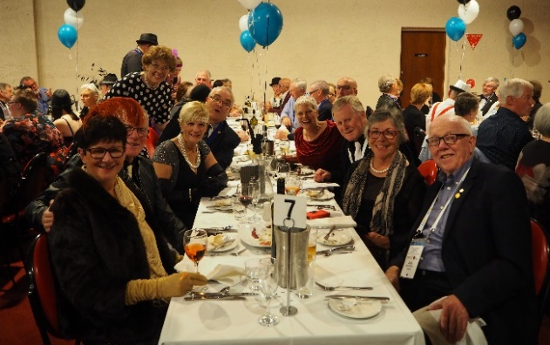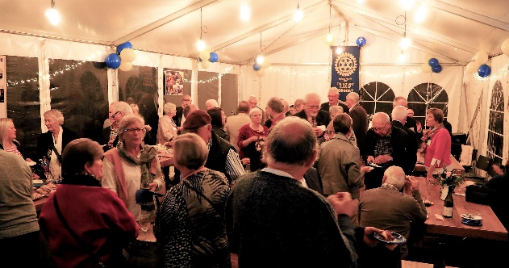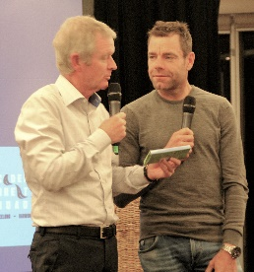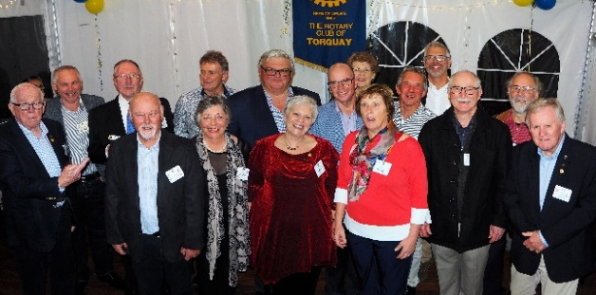
MEMORIES OF MARY JANE ELLIOTT (27 April 1933 - 6 May 2018)

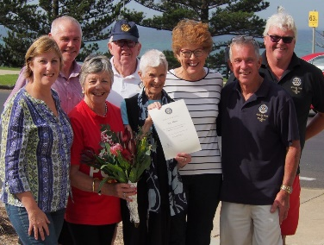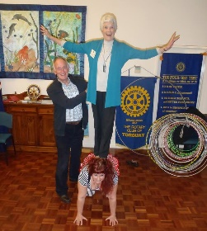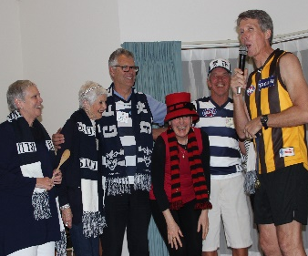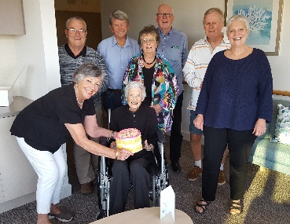
YOUTH SERVICE  My sincere thanks to those members who contributed to the Youth Service Portfolio activities over the past twelve months. While the Rotary Club was not able to participate in all of the youth programs available for various reasons, there were opportunities to be involved in new activities.  Gerard McNamara  Director Youth Service  2017/2018 |  |  |  | 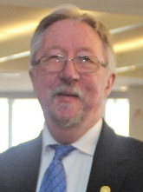
STUDENT ENCOURAGEMENT AWARDS
The Club continued the practice of providing annual encouragement awards of $1,000 each to the Surf Coast Secondary College, Torquay College, Bellbrae Primary School and St Therese Primary School. These awards are very much appreciated and enhance our presence in the local community.

WINCHELSEA PRIMARY SCHOOL LITERACY PROGRAM
For the fourth year in a row the Rotary Club made a grant of $1,500 to the Winchelsea Primary School for the development of resources for the school literacy program. I was pleased to attend the school on behalf of the Club to present the cheque to the School Principal.

OTHER ACTIVITY
At the Club meeting on 26th March, a representative from Lorne P-12 College spoke about their Victorian Certificate of Applied Learning (VCAL) project. As part of this project, Lorne students will travel to the Santa Teresa Aboriginal Community near Alice Springs in the Northern Territory. There they will have an opportunity to share experiences with local school children. Later in the year the students from Santa Teresa will make a return journey to the College at Lorne. Our Club presented the College with a cheque for $1,000 to help sponsor this great youth exchange project.
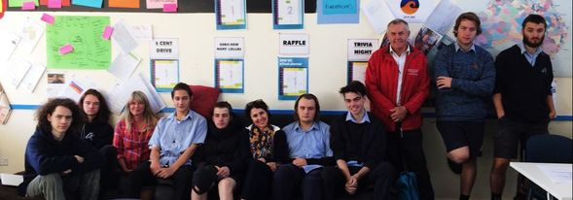
Students visiting Santa Teresa (NT) from Sunday the 27th of May to Friday the 1st of June
Their project can be followed at https://seatosandtrip.weebly.com/

COMMUNITY SERVICE  Firstly, I would like to thank all members of the Rotary Club of Torquay for your participation in the many events we have been involved with during the past year. Your commitment to the club activities enables us to take on these events, and have Rotary involved in our community. Thank you to all the Rotarians, Partners, families and friends who have helped out on community events during the year.  Michael Reed  Community Service Director, 2017/18 |  |  |  |  |  | 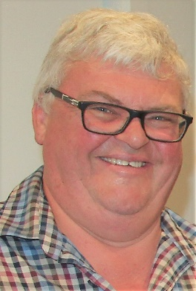
SAUSAGE SIZZLES  Our Sausage Sizzles continue to be very worthwhile for our club. We raise good revenue from the BBQ’s we run at community markets, Bunnings, Rip Curl and other events.  Staffing of the BBQ’s at times can be challenging. I would like to thank all the helpers who ‘stepped in’ at short notice when shifts were ‘light on’.  Many Thanks Mal for your coordination of the BBQ roster and Trailer. |  | 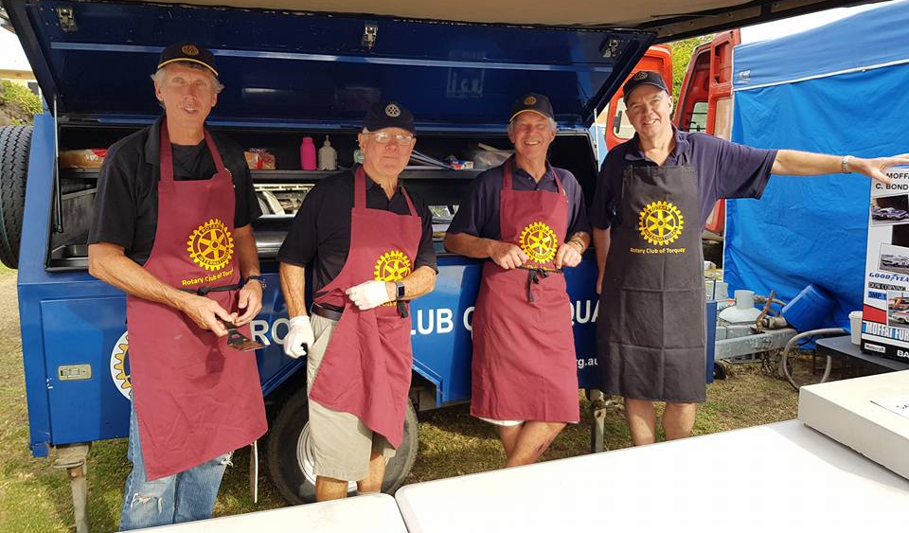
NIGHT JAR PARKING  The night jar parking is another terrific source of income for our club. As there are no expenses for these events, all funds taken from the parking are retained in our fundraising account and make up part of our annual Community funds distribution. |  |  | RELAY FOR LIFE  The Rotary Club of Torquay continues to support, and be involved with this event, after initiating this on the Surf Coast. The event has raised over $500 000 in over eight years for the operations of the Cancer Council Victoria. Thank you for participating in the Rotary Team and those volunteering in running the event.
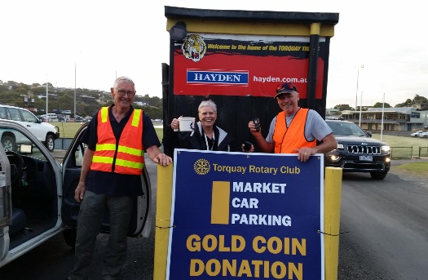 | 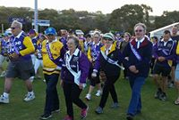 |  |  |  | 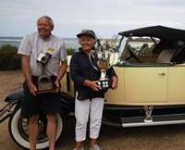
MOTOR SHOW
Our annual Motor Show was again a huge success. With so many entries this year the area was well packed! Needless to say, there was a great variety of vehicles and plenty for all to see …. And dream about. Thanks to the organising committee for coordinating the event.
Well done to all Club members, Partners and Rotary friends for assisting in this major event.
The Motor Show has become a significant fundraiser for our club. This event is now firmly on the social calendar of the motoring public, with many enthusiasts returning each year. The results of all the effort put into this event, raises much needed funds which are used to help the less fortunate.
This year sees the most successful show to date …. Well Done!!
STRATHEWEN PRIMARY SCHOOL  This is the ninth year that our Club has been hosting the children, parents and friends from this school since the Black Saturday fire that traumatised their whole community. It is always pleasing to see the smiles from these people ……enjoying a day at the beach, and enjoying the food and hospitality provided by our club and members.  Thanks to Gail Chrisfield and Alan Anderson for co-ordinating this special day for the Strathewen community.  SPRING CREEK COMMUNITY HOUSE  A donation of $1,650 was made to the Spring Creek Community House to assist with the publishing and distribution of their Springboard Newsletter. With our donation, we help in providing 6,000 copies of this publication to the greater community of Torquay. It has also entitled our Club to have the Rotary logo displayed on the front page of Springboard and an opportunity to have our own articles and photos in each of the four editions published during the year. Another great way to promote an understanding of Rotary in our community. |  |  |  | ANZAC DAY  A lovely morning this year saw many people attend Point Danger for the dawn service. A very strong team of Rotarians were in attendance, and helped make it ‘happen’, through roles in crowd control, handing out orders of the service, collecting donations, manning the BBQ at the Gunfire Breakfast and selling raffle tickets. Numbers attending the service were good this year, helping us to raise well needed funds for the Torquay RSL.  Many Thanks to John McDonald for liaising with the Torquay RSL and coordinating this event.  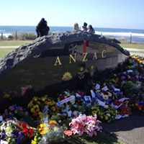
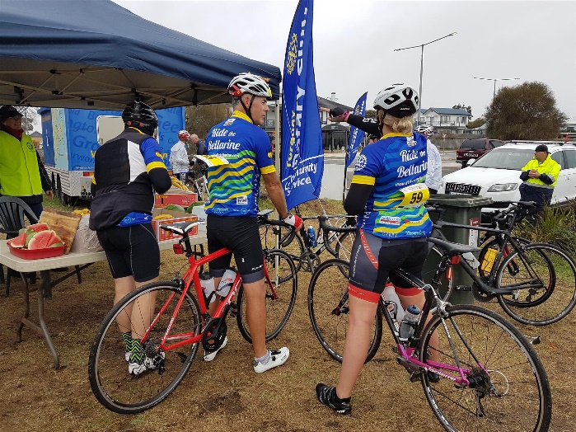 |  |  |  | RIDE THE BELLARINE  Our club was well represented in the annual “Ride the Bellarine”, a District fundraiser for the End Polio Project. This is an event all Rotary Clubs in the Geelong area participate in, to raise funds for eradicating Polio. Many thanks go to Greg Plumridge who is not only our club representative but is also on the organising committee. The weather was a little unfavourable this year and saw the number of riders down on previous years.  Thank you to all Rotarians and partners who volunteered their help with marshalling, driving the emergency vehicles and with setting up and packing up the riding course.
BATTERY RECYCLING

It is pleasing to see the amount of used batteries deposited in these recycle bins, keeping the used batteries out of land fill.
Thanks to Rudi for his ongoing commitment and coordination of this community service.

BOOK FAIR

In January, we held our annual book fair. Rhonda Anchen did a fantastic job coordinating and publicising the fair. Thank you to all who helped. With well over 15,000 books displayed, there was a lot to set up, help out on the days of the fair, and pack up. It was very well received in the community and supported by many locals and holiday makers. This year we raised well over $7,000. Great Effort!

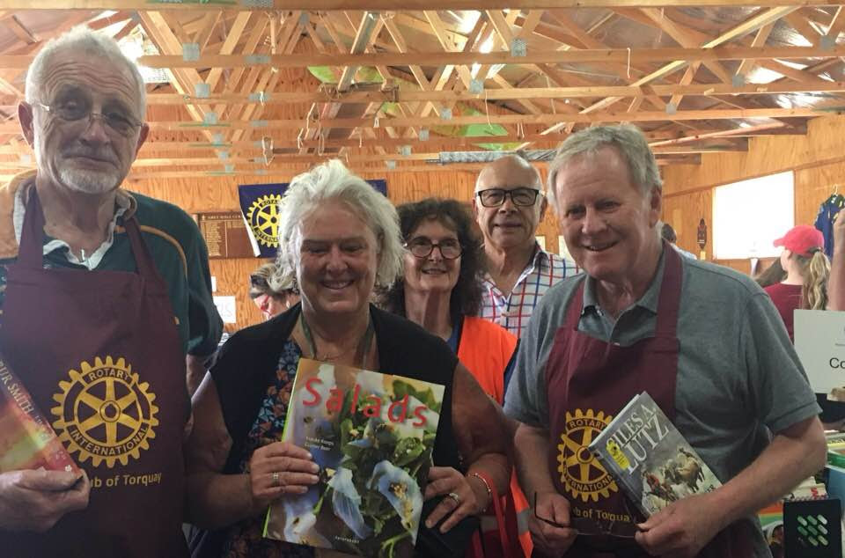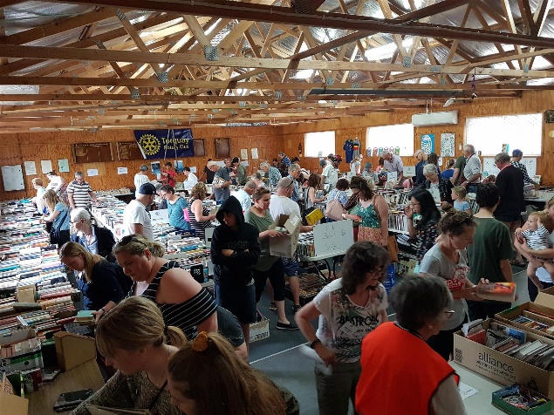

PROBUS
The creation of Probus Clubs is a Community Service responsibility of Rotary Clubs.

Probus is an association of retired and semi-retired people who join together in clubs, the basic purpose of which is to provide regular opportunities for them to keep their minds active, expand their interests and to enjoy the fellowship and company of new friends.

The Rotary Club of Torquay has been very active in this field over the years.

In 2017, Torquay had two Ladies’ Probus Clubs, one Men’s Probus Club and three Combined Probus Clubs. There is also a Probus Club in Anglesea.
In late 2017 the Club Board realised that due to the popularity of Probus among retirees, some Clubs had waiting lists of those wishing to become part of this activity. The Board agreed to commence the process of determining whether there were sufficient eligible people who would be interested forming a new Probus Club.

The first public interest meeting was held in November of that year attracting some forty interested people to the meeting. Subsequently in February 2018 the first formation meeting of the Probus Club of Torquay Jan Juc was held with sixty in attendance. Interest in the new Club gradually increased so that by the April meeting there were over eighty members. In addition, a number of new enquiries have been received. It is expected that membership will reach the ceiling of one hundred very soon.

Probus as an organisation is alive and well in Torquay due in part to the efforts of your Rotary Club.

I would like to thank you all for your time and commitment to The Rotary Club of Torquay Community Programs, Events and BBQs. Together we have raised funds and provided opportunities for our local Community, for our Rotary District and Rotary International Projects.

Michael Reed

MEMBERSHIP  The social, charitable and reputational capital we enjoy on the Surf Coast does more for our image and community standing than that could be achieved by a mere Membership Director. We have gained in size and calibre(!) to 42 members now.  John Oswald transferred to us from the Rotary Club of Ballarat West in July 2017.  In September 2017 Jan Emmett (sponsored by Geoff Dawson), Garth Hammonds (sponsored by Kelly Binyon) and Trevor Hall (sponsored by Greg Birchall) were all inducted into our Club.  John, Jan, Garth and Trevor have hit the ground running, with each pursuing an interest of their choice. And that's what it's about - contributing, sharing knowledge and skills, and having a good time and companionship whilst you're at it. | 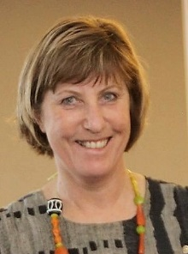
Our latest new member is Ben Featherston (sponsored by John Oswald) who was inducted in April 2018. Ben is a respected local Audiologist in Torquay and Winchelsea. We have ideas for you Ben! Ben has expressed an interest in joining the Youth Committee next year under the chairmanship of Kelly Binyon. Engaging youth and recruiting younger members are key goals for our club.
Past President Jeanette Crowther resigned in September 2017. Thank you, Jeanette, for your drive and energy and we wish you well for the future.

We sadly lost Mary Elliott just recently. She had been a long-time member and was awarded Honorary Membership as a sign of our affection and admiration for her myriad works, particularly promoting Organ Donation.
We will miss Rudi Schols, who will not be renewing his membership in 2018/19, which means we will start the new year with 41 members.

Amanda Hough
Membership Director, 2017/18

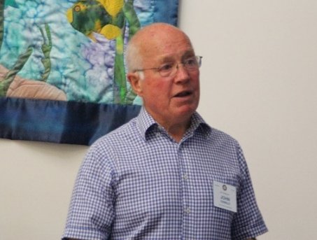 | 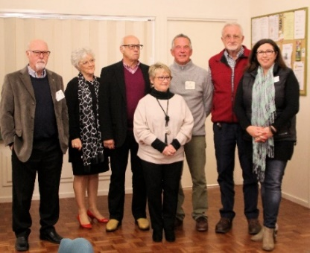
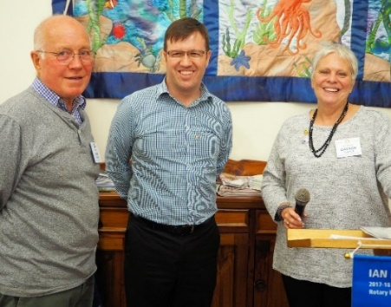
CLUB SERVICE  Thanks to the organisational skills of Bruce Smith we have had an enjoyable and productive program of weekly meetings over the 2017/18 rotary year under the presidency of Gaynor Schols. Bruce managed a well-balanced mix of speaker presentations, club planning and strategy, interspersed with a range of special events such as fish and chips on the beach, dinner meetings at Jan Juc surf lifesaving club, Brownlow medal and Melbourne Cup Eve celebrations, Christmas in July, some Happy hour drinks gatherings, Fireside chats held at the homes of Rotarians, Book fair and Motor show related meetings and a celebration of the 30th anniversary of the formation of Torquay Rotary Club. |  | 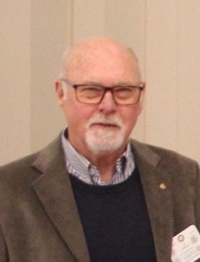
In all this Bruce managed to balance the need for Rotary work and planning with some time for fellowship and some serious fun.  As a result, membership has held up strongly with a net growth in membership for the year. Sergeant Trevor Pickles, supported by David Mitchell and Bruce Smith, kept the mood light and the laughs coming while topping up the Club account with astute fines on a weekly basis.  After an investigation into a Shire-run venue, the Board opted to remain at the Lions Village venue for the present. Rod and Lorraine Sullivan have kept us well fed and watered throughout the year.  The meeting format seems to work well for this kind of Rotary club and thus far nobody has suggested to me that we make radical changes to the style and form of the weekly meetings.  Thanks to Michael Reed and Peter Bollen for seeing to the setup of the room prior to meetings. Mike also kept the refrigerator well stocked.  I am pleased to be handing over the Club Service Directorship to Bruce Smith for the upcoming year. Best wishes Bruce, I am sure you will lead us well as we go forward.  Greg Birchall  Club Service Director  2017/18 | 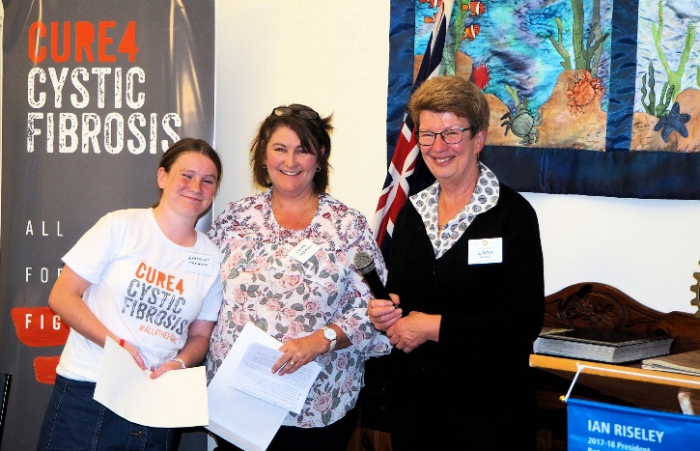  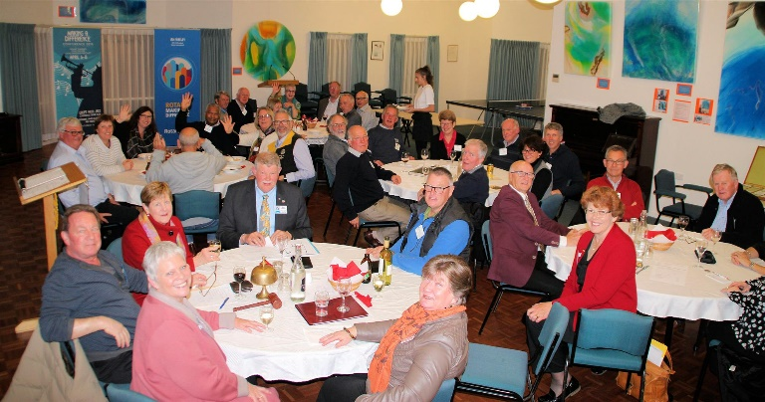  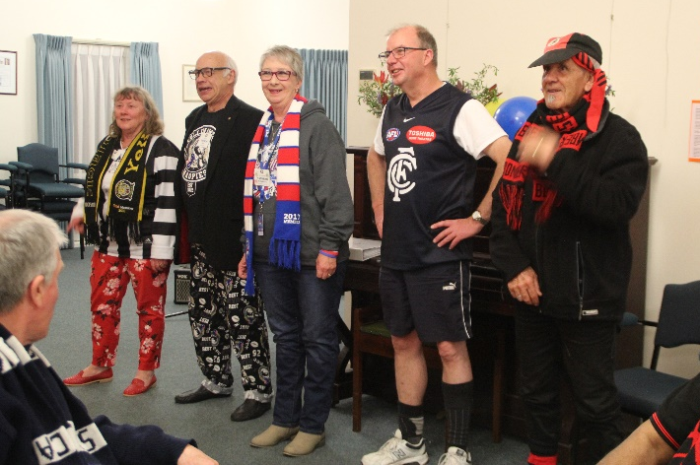

INTERNATIONAL SERVICE  Thank you to the members of the International Service committee for your interest and commitment to international Rotary programs this year.  Lesley Shedden  International Service Director  2017/18  Finally, clean drinking water for the people of Kalimpong, India. | 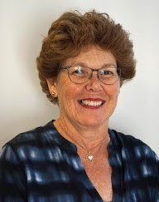

In conjunction with the Rotary Club of Benalla, $6,000 was provided by the RC Torquay to install water filters on tanks at the Awake and Shine school in a remote village in India. This funding was provided in 2017 with the filters installed in Feb 2018.
Many delays occurred in the delivery and installation of the filters, with numbers of causes including government regulations, a political strike and travel difficulties. Ultimately, smaller filters than originally planned were purchased and transported in the luggage of Benalla Rotarians going to Kalimpong to install them.
The outcome is clean water for the people of this remote village, something they have not previously had. The previously dirty water was causing high levels of disease amongst these villagers.
This is a fantastic outcome for this international project.

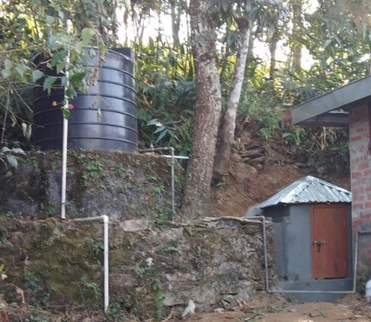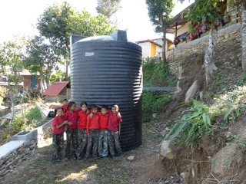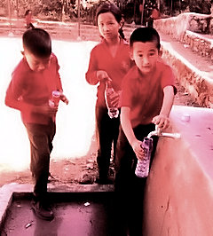
Support for ROMAC and Interplast

Once again, RC Torquay has supported these two significant health related international projects with donations of $2,091 to each, thanks to the success of the Dine with Cadel Evans event.

Interplast sends teams of volunteer plastic and reconstructive surgeons, anaesthetists, nurses and allied health professionals to provide life-changing surgery and medical training in 17 countries across the Asia Pacific region.
ROMAC (Rotary Oceania Medical Aid for Children) provides life-saving and /or dignity restoring surgery and specialist treatment for children from developing countries not accessible in their home country. 2018 is the 30th anniversary for this amazing Rotary program, which has now treated 508 children.
ShelterBox

We made a donation of $2000 to ShelterBox, which provides emergency shelter and tools to families robbed of their homes by disaster. A single sturdy green ShelterBox contains a family-sized tent that protects people from the elements and provides a safe space in which people can start to recover from physical and emotional trauma.
The contents differ depending on the disaster and the climate, but items such as solar lights, water storage and purification equipment, thermal blankets and cooking utensils help start the process of creating a home.
 | THE ROTARY FOUNDATION  Established in 1917, The Rotary Foundation is organized as a public charity operated exclusively for charitable purposes.  Donations to The Rotary Foundation are split between the World Fund and the District Designated Fund (DDF). Clubs can apply for grants from the DDF for both global and district projects.  Polio Plus is a separate fund used for the eradication of Polio. For every dollar donated by Rotary from this fund the Bill and Melinda Gates Foundation donates two dollars. |  | 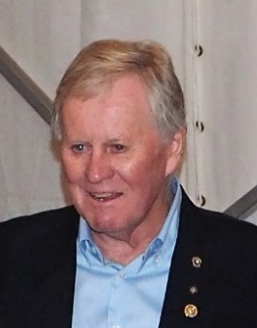
POLIO CASES REPORTED THIS YEAR
Countries | Year-to-date 2018
 | WPV | cVDPV
Afghanistan | 7 | 0
Democratic Republic of The Congo | 0 | 4
Pakistan | 1 | 0

Our Donations to Foundation
Our Club donated AU$5,330 to the Foundation Annual Fund this year.

Polio plus
Our share of the proceeds from Ride the Bellarine plus members’ donations to the value of $635 have been paid to Polio Plus. The club also donated $100 in the name of Jessie Harman, for her help with our Strategic Planning.
District Grants for our Club  Traffic Control Training was completed in February with District and our club each paying AU$2810. Brian Mynott, Geoff Dawson, Bruce Smith, Terry Charlton and Alan Anderson were qualified, and new equipment was purchased.  An application has been submitted for a new District Grant to refurbish the BBQ trailer for the sum of $2790. The club will contribute a similar amount.  Training for Grant Accreditation  This must be done every year to allow a club to apply for grants. Gaynor Schols completed this training for our club at District Assembly. This qualifies our Club until May 2019.  Past DG Chris Sims  Foundation Chair  2017/18 |  | 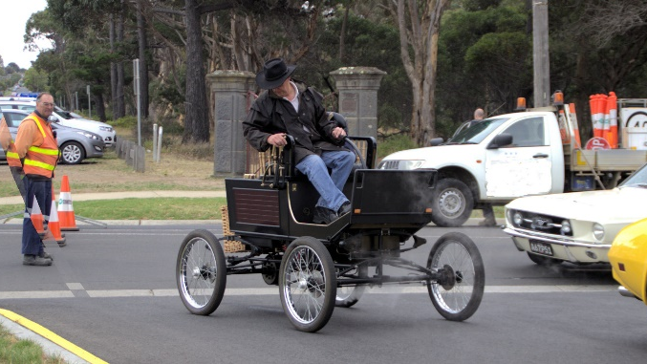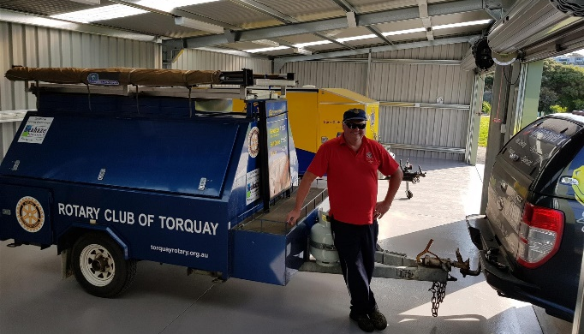
 | VOCATIONAL SERVICES  My sincere thanks to the members of the Torquay Rotary Club for their contribution towards the activities in the vocational services portfolio.  Mock Interviews  The club has an ongoing role in supporting local schools to provide invaluable training for students in the art of employment application and interviews. |  | 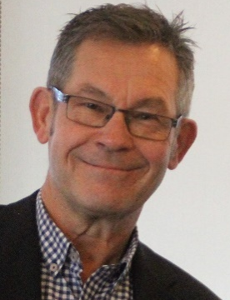
Members assisted the Grovedale Secondary College in the latter part of 2017 and are currently working with Surf Coast Secondary College in the same process. Many thanks to the Rotarians and others who have supported these programs.
Diversitat
I was privileged to attend a graduation ceremony of young immigrants who had passed through a mentoring program devised and supported by Diversitat. The pride and sense of achievement shown by both the graduating and their mentors was wonderful to experience. We will continue to offer our services to this worthwhile group.
Annual Community Award
A long-term strategy to establish an annual Torquay Community Award has been launched this year, and although in its infancy, the presentation of such an award will be an excellent opportunity to recognise outstanding individuals in our community and also invite potential members into the club.
Richard Mierzejewski
Vocational Service Director
2017/18

PUBLIC RELATIONS  The electronic world in which we all now live continues to revolutionise almost everything we do and a Rotary Club is no exception.  At the Public Relations Sessions at District Training Assembly held in April it was clear that the Rotary Clubs in District 9780 are at vastly different stages of progress when it comes to keeping pace with these relatively new media.  Greg Plumridge  Public Relations Chair, 2017/18 | 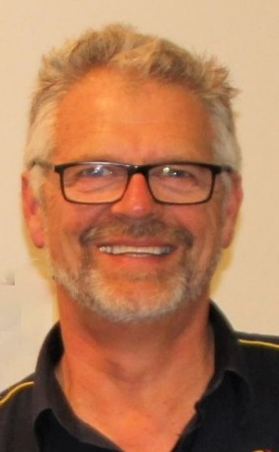

That time old chestnut that has challenged Rotary Clubs for as long as I can remember….How to attract new members, was the focus of everything we discussed in the sessions. The mission for all clubs’ Public Relations efforts is to better communicate who we are, and what we do, to our immediate community and hopefully that will lead to increased interest, support and membership.
This message is conveyed by every single item that represents us in the community, right down to the signs on our BBQ trailer which are becoming somewhat weathered and shabby. Thanks to a great effort by Lesley Shedden processing the application, we expect to soon receive a District Grant to fund a refurbishment of the trailer.

As usual, we are extremely grateful to James Taylor and The Surf Coast Times, The Geelong Advertiser and Spring Creek House for publishing our events and achievements in the local print media.
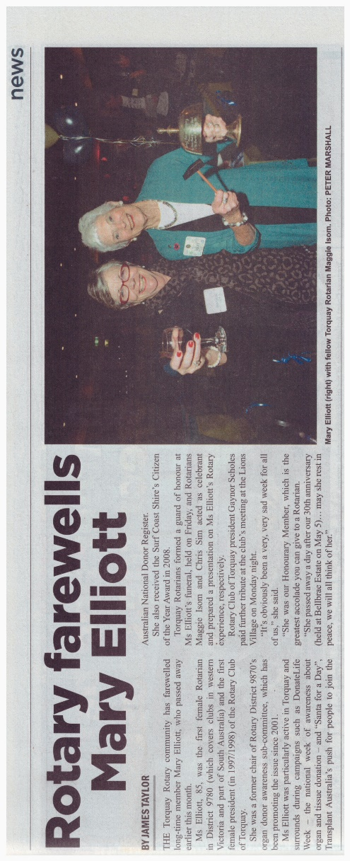

As Google and Facebook continually shift the processes and goal posts on Social Media and Search Engine Optimisation (SEO) it is vital that we are not lagging behind with what we do.
Whilst there are continual changes and tweaks that can be made to improve our reach through the Internet and Social Media I am pleased to say that we are performing a lot better than the average.

Thanks must go to Kelly Binyon and Rudi Schols, the nucleus of the Public Relations Team, who have worked hard to improve our coverage and reporting of our key events across all media, with Facebook pages and Websites for both the Club and the Torquay Rotary Motor Show along with the Bulletin, and our latest addition, the new meeting attendance program, “Whoozin”.

Hopefully the articles have achieved the aim of being concise, colourful and informative to our audience, and the implementation of “Whoozin” will assist with simplifying the process of promoting meetings and members registration for attendance.

Throughout the year we have produced promotional flyers and posters for our Club, the Motor Show and Book Fair.  With 15 Rotary Clubs in the geographically small Greater Geelong region there is a lot of competition to recruit potential new members however in recent years, perhaps since Ride the Bellarine arrived as a combined Geelong Clubs event, there has been a real camaraderie and pooling of efforts between the Clubs.  In March our Club participated the first Rotary Expo which was held at the Steampacket Gardens Sunday Market, this was the first collaborative effort of all of the Greater Geelong Clubs to promote Rotary publicly in the community. Thanks to Lesley, Gaynor and John Oswald for manning our shift. | 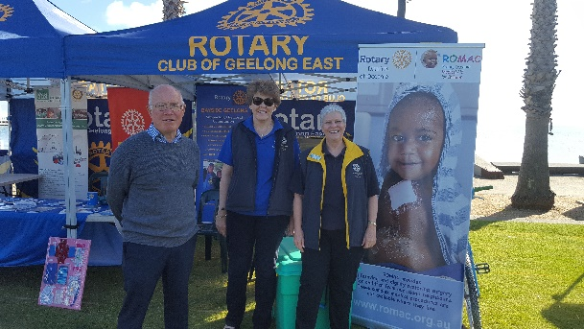
The Club’s 30th Anniversary milestone enabled an opportunity to reflect and revisit the history of the club in pictures, and such was the interest in them that a USB stick containing the collection will be available for all members.

Whilst I have mentioned some Members individually the task of Public Relations of our Club is a task that every member of the Club assists with, even if it is something as simple as the sharing of a Club Facebook posting.
So, a big thank you to all of you, and while we will shortly lose Rudi Schols from our membership, I am sure he will never be far away and hopefully can still assist with a few special projects.

