Leah Kissick’s RYE February Report Photos

the view from on top of Bluetooth’s barrow in Jelling, overlooking the flat horizon

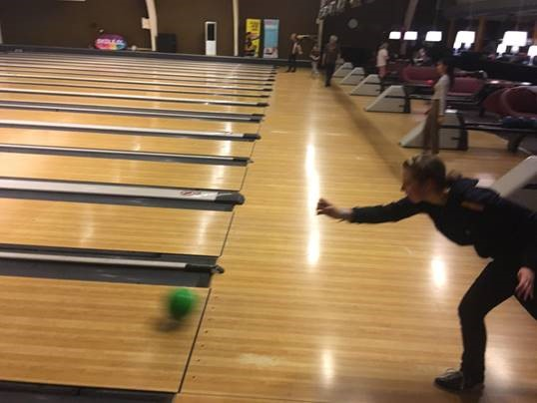
not a strike but me saying yes to everything
All new Rotary Students in Denmark from Australia (lots), Argentina (4), Brazil (2) and New Zealand (3) on Introcamp
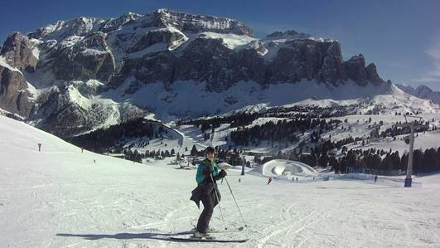
Leah on skis in Italy

