The Inspirer
District 7530
2018-2019
January 2019
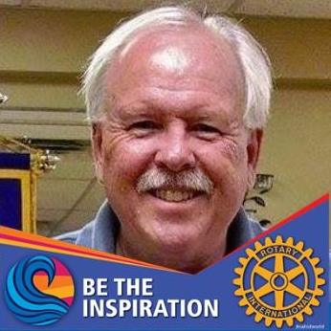
Greetings District 7530 Rotarians!

First, a very happy new year to you! You’ve accomplished so much in the first half of the 2018-2019 Rotary year, but don’t let down. There are six months left in the year and we still have much to do:
- Our District staff will continue to support your clubs. That’s our number ONE priority.
- We’ve been tasked to combine our District with our southern neighbor, District 7550, by July 1 2019. We have a transition team in place and working hard to make this happen. Our new District number will be 7545. This task will have virtually no effect at the club level. We’re very optimistic about the opportunities our new District will have.
- Our Presidents-Elect Training Seminar (PETS) is scheduled for March 15-16 at the Flatwoods Conference Center/Days Inn. All club presidents starting office on July 1 must attend (or attend another District’s PETS) before they become president. Your club president or Assistant Governor has more information.
- Rotary International (RI) President Barry Rassin and wife Esther will be in Buckhannon the last weekend of March to help several clubs celebrate recent 100th birthdays. Barry will be the first RI President to visit our District while in office. This is truly an honor.
- Our last District 7530 Conference will be at Oglebay Park in Wheeling on May 3-5, 2019. We’re about to upload our registration information so everyone can register. The Conference is designed for EVERYONE in your club and their partners, not just the leaders. Bring your families, too; Oglebay Park is packed with fun things to do. We’ll also have a Rise Against Hunger food packaging event, and we’ll need volunteers for that. Mark your calendars!
- We’d like to welcome the chain of District Governors for the new District 7545: Shari Messinger, Barboursville; Sean Sawyer, Fairmont; Coop Cooper, Tucker County and Roger Topping, Princeton. Congratulations, Lady and Gents. Awesome years are coming!

January through June is a transitional period when the new club presidents and District governors do most of their planning, training, and getting ready for their years as servant leaders of Rotary. Ideally, this is a time when the current club presidents and the current District governors help to mentor the presidents-elect and the governors-elect through the transition. It is important for the continuity of the Rotary clubs and for Rotary in general that the current and future leaders work hand-in-hand to ensure a smooth transition. If you haven’t designated a club president-elect, please do that ASAP, and get them ready for PETS. PETS is the ultimate training program for them, and gives them a chance to meet other club presidents.

Have a great 2019, and remember to Be the Inspiration!

Mike Davidson
District 7530 Governor, 2018-2019

Rotary Club of Morgantown North Sets a New Record
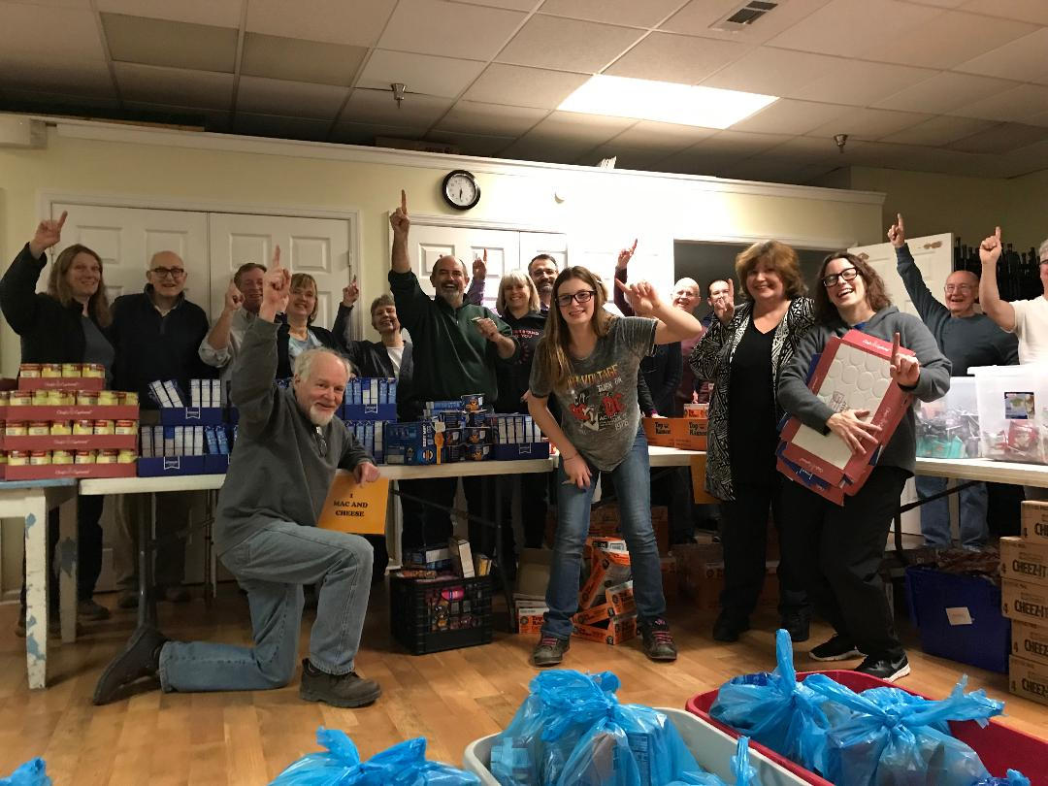
By Cathie Falvey
On the first Wednesday of every month, Morgantown North Rotarians gather at Scotts Run Settlement House at 6:00 p.m. to pack food to give to area school children to take home. Food insecurity is a serious issue affecting children in our area, so packing food for backpacks is a regular activity for Rotarians and other service organizations in the Morgantown, WV, area.
Thanks to an especially large turnout, on January 2nd, Morgantown North Rotary Club achieved a new club record by packing the most food in the least amount of time ever. Members and friends filled 700 bags for backpacks in just half hour! Rotarian Mary Wimmer, who took the photo, made a point of capturing the time on the clock.
Many hands make light work, and it was an exciting way to begin 2019. We invite fellow Rotarians and others to join us or try to beat our new Scotts Run backpacking record.

Rotary Club of South Fairmont
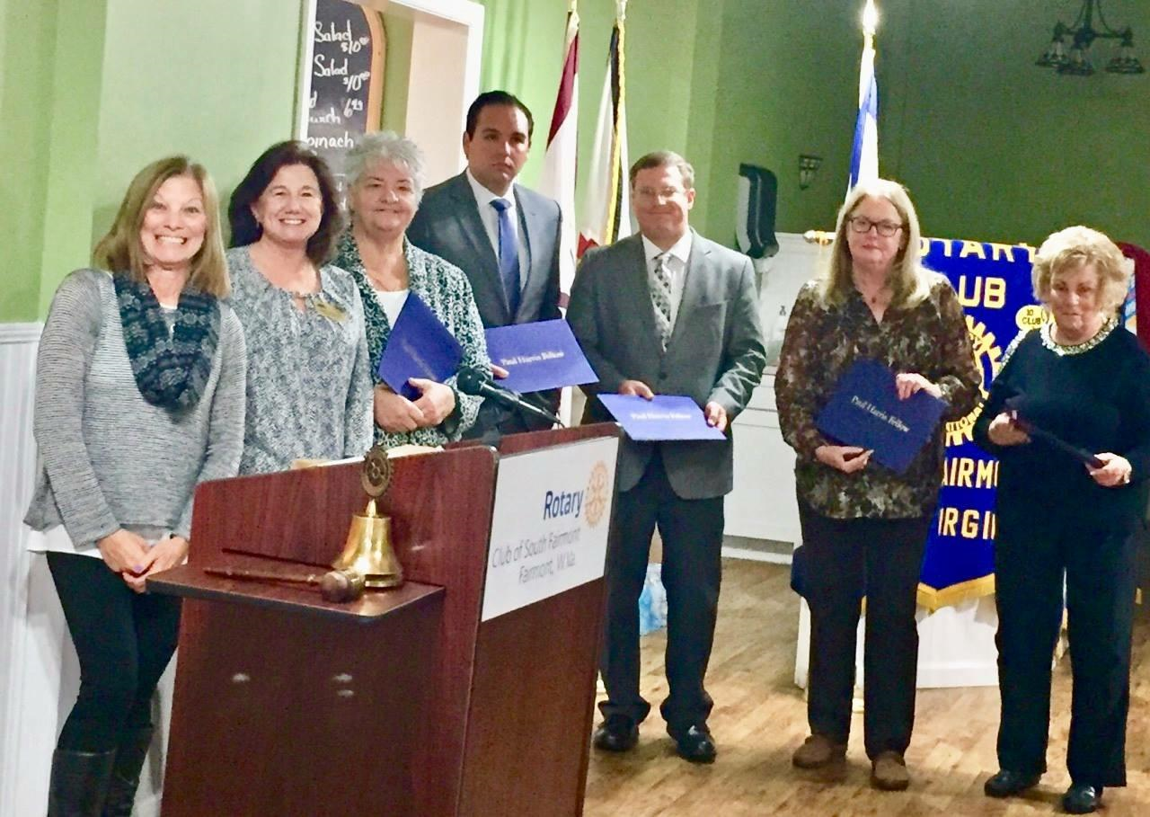

On November 28, 2018, the Rotary Club of South Fairmont presented 5 member with their Paul Harris Fellow award.

From left to right: Patti Hodges, Foundation chair, Debbie Michalski, Club President, Belinda Biafore, PHF, Taylor Downs, PHF, Spencer Ford, PHF, Kaye Widney, PHF, and Sharon Swearingen, PHF.

Rotary Club of Cheat Lake

The 28th annual Cheat Lake Rotary Dream Benefit was held on September 28th. This is our annual elimination dinner held at Lakeview Resort and had approximately 175 people attend. The club raised around $20,000 to go toward Cheat Lake community projects and scholarships for University High School students.

On October 23rd we had a festive evening mixer with Wine and Cheese and live entertainment provided by Mike Arbogast at the WV Botanic Gardens. With over 100 people in attendance, there was also a live auction that raised $850 for Polio Plus in honor of World Polio Day.

Our annual Holiday Party was held at the Waterfront Marriott Hotel on December 16th and Shirley Dempsey organized a silent auction that raised another $1,400 for Polio Plus. Fun was had by all that attended with music provided by The Craigs.

The Cheat Lake club continues to be active in bringing in new members. 11 new members have joined the ranks since July 1st.

Our annual Radiothon will take place in March, so tune into 100.9 Jack FM to hear the advertisements of our local supporters. Contact a Cheat Lake Rotarian for information on how to participate.

District 7530 Web Site & Facebook Page

District 7530 is well represented on the World Wide Web with a new web site developed last year, and a Facebook page.
The web site address is: http://rotarydistrict7530.org
We encourage all clubs to send information we can insert into the Club News section. Not well used at this point, the web site could eventually serve as a District archive of club and district information. It is our hope to build this web site to benefit our clubs and district.
For the website, send information to: Bonnie Branciaroli bonniesuemark@gmail.com
We are asking all District 7530 Rotarians and clubs who have Facebook pages to “Like” and “Follow” our district Facebook page.
The address is: http://www.facebook.com/RotaryDistrict7530/
Help us build a stronger social media base by “Liking” our page and Inviting five of your friends to do the same. Also, feel free to Share information from your Club page to the District page.
For more information on the District Facebook page, contact Sharon Welsch, swelschmk@comcast.net

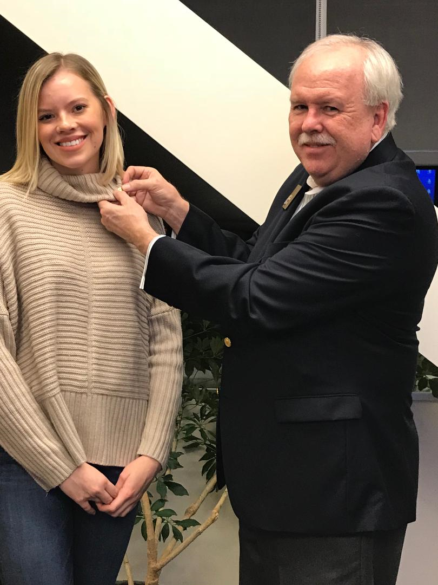
District Governor Mike Davidson inducts new e-club member, Savannah Ashworth.

Rotary E-Club of District 7530
Also known as the Mountain State E-club, Rotary E-Club of District 7530 is proud to announce three new members to the club since July 1. The state’s only E-club welcomes:
• Savannah Ashworth, a senior at West Virginia University, and sponsored by E-Club founding president and current Membership Chair, Richard Phalunas, Savannah will be attending graduate school at WVU.
• Lisa Gum, a long-time resident of Buckhannon, West Virginia, recently moved to Camden, North Carolina. She has joined Mountain State Rotary E-Club to maintain connections with her home state. Lisa has worked in a variety of settings as a Speech-Language Pathologist and is now employed by Suffolk Public Schools in Suffolk, VA.
• Welcome back! Andrea Salina Fleming, a former member of the e-club in 2012. Andrea is the Executive Director of the Fairmont Community Development Partnership in Fairmont. She is also a published children’s author and an adjunct instructor at both Fairmont State University and Pierpont Community and Technical College.
MAKE UP A MISSED MEETING!
Rotary E-Club of District 7530 extends to all Rotary clubs within and outside the District an opportunity to make up a missed meeting by simply visiting our website and attend a meeting online. It’s that easy. Just visit https://msre.org/page/how-to-do-a-makeup , follow the prompts, attend the meeting, fill out the make-up form and we’ll do the rest.
CHILDREN’S BOOKS SERVICE PROJECT
The e-club provides children’s books to the North Central WV Community Action Assistance program in Kingwood. The club’s goal is 50 books delivered each month. We are accepting new or gently used children’s books. Contact president, Diana Martinelli at martinellidiana@gmail.com if you are located in the Morgantown area, or ship the books to Diana Martinelli, 181 Donna Ave., Morgantown, WV 26505.

PETS - March 15 & 16, 2019
ALL ATTENDEES MUST REGISTER.
Please mark your calendars now to attend the District 7545 PETS March 15-16, 2019
Flatwoods Days Inn & Suites and Conference Center -- 2000 Sutton Lane -- Sutton, WV 26601
Please make your own hotel reservations by contacting: Flatwoods Days Inn & Suites at 866-700-7284
Room rates are $ 89.99 per night (single or double) if made by March 1, 2019
Those who are required to attend: President Elects (District 7530 PEs, $100; D7550 PEs, no cost).
Those who should attend: President-nominees, Assistant Governors and anyone interested in developing stronger club leadership (Cost $100 per person).
PETS registration starts at 11 a.m. on Friday, March 15 and the Opening Session/Lunch begins at 12 Noon.
The Seminar will include outstanding speakers as well as breakout group discussions addressing various Rotary club topics. Sessions will be conducted from Noon on Friday and will end Saturday at 4 p.m. Your PETS fee includes lunch and dinner on Friday AND breakfast and lunch on Saturday.
If you have any questions, please contact District Governor Elect Shari Messinger, (304 633-0037). If you need help in registering for PETS, please contact Deb Halsey-Hunter at debhunter@citlink.net or 304 920-2131.
I look forward to seeing everyone on March 15.
Shari Messinger
Rotary International District Governor 2019/2020
District 7545, WV
TO REGISTER—Log into DACDB; go to the Calendar; go to March 2019 and find the March 15 date—click on the PETS Training and follow the directions.

Morgantown North Rotary Partners with Circle of Friends to Provide Meals

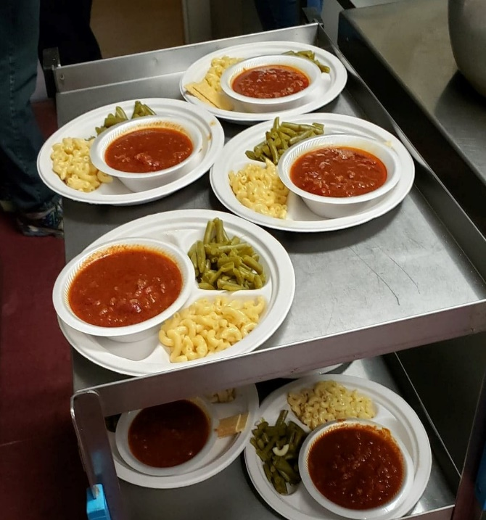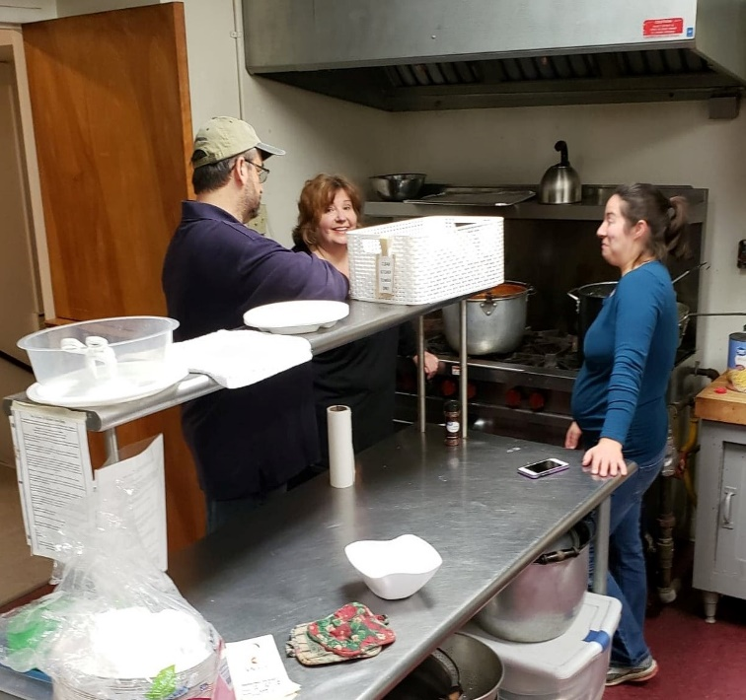

By Cathie Falvey
In cooperation with Morgantown’s Circle of Friends organization, Morgantown North Rotary provides dinners for people in need on the last weekend of months that include five weekends. The meals are prepared and served at Wesley United Methodist Church in downtown Morgantown.
Saturday, December 29th, was one of the busiest days the club has seen, with a total of 90 meals served! Annie Fowler, wife of Rotarian Zach Fowler, and her mom plan the meals and do the shopping, and Annie directs the Rotarians who help with the cooking and dining room operation.
Saturday’s dinner consisted of chili, mac and cheese, green beans, chocolate pudding, cookies, lemonade, and coffee, and a variety of additional desserts donated by Wesley parishioners. The Everett family from Wesley also volunteered, serving meals, bussing tables, and taking orders for seconds. Sunday was more of a typical-size crowd. At least 65 first servings of barbecue chicken breasts, potatoes, and vegetables were served, and a charming father and son team from Wesley also came to help out.
Morgantown North Rotary is honored to be able to support the efforts of Circle of Friends, which has been providing free meals in Morgantown for decades. We are especially grateful to Annie and her mom for their hard work and meticulous planning, which allows our club to provide a minimum of 120 meals for about $250 approximately four times a year.

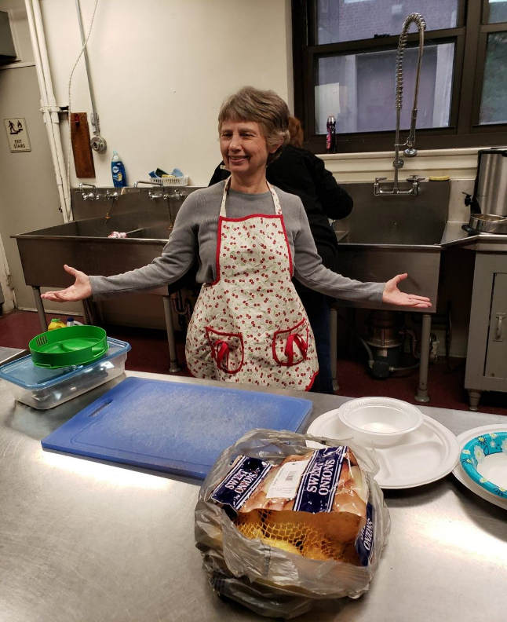
Rebecca Hunn cooking 120 meals, I love the apron.
Rotarians At Work!

Bridgeport Rotary Club
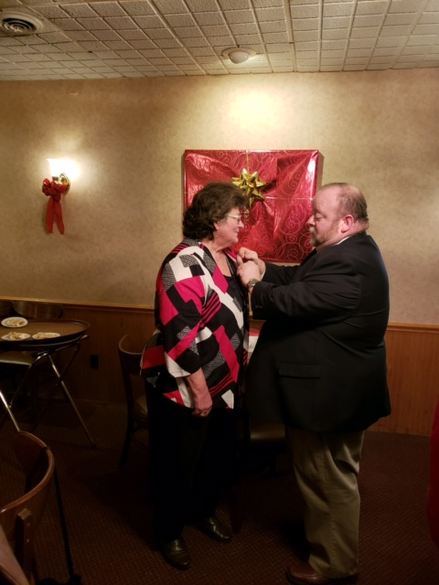
On December 18 the club had its annual Christmas Party at Raymon’s Restaurant with the majority of members and spouses attending. The ceremonies were conducted by Brad Ford as he spread the holiday cheer in his own unique way. The group was honored to have DGN Sean Sawyer present and he made a presentation of a PHF +8 to Christel Shumate.

ROTARY CLUB OF KINGWOOD
The Rotary Club of Kingwood enjoyed a variety of activities during the fall of 2018.
The 77th Buckwheat Festival -- the club entered its float in the Farmers’ Day Parade on September 29th with a special theme featuring club president, Bob Meissner in a lamb’s costume, Tarrell Ries in a pig’s costume and Whitney Westbrook in a cow’s costume. She also carried a sign, “Eat More Lion” to add to the fun for the day.” The Lions Club has an on-going friendly rivalry. Additionally, Rotarians contributed time and effort to the many activities of the festival. (See attached photo.)
Dictionary Distribution -- All 3rd grade students (0ver 300 children) received their own dictionary in October. This annual project is well received by teachers and parents.
Wreaths Across America – Rotary Club of Kingwood had its first ceremony as participants in the “Wreaths Across America” celebration (2nd Saturday of December). This nation-wide program endorses wreaths being placed at every veteran’s grave across the nation. 1400 cemeteries currently participate in the program.
Luminaries Lighting Christmas Eve – Carrying on an annual tradition, the Rotary Club of Kingwood placed luminaries on Main Street contributing its part in a community-wide tradition on Christmas Eve.
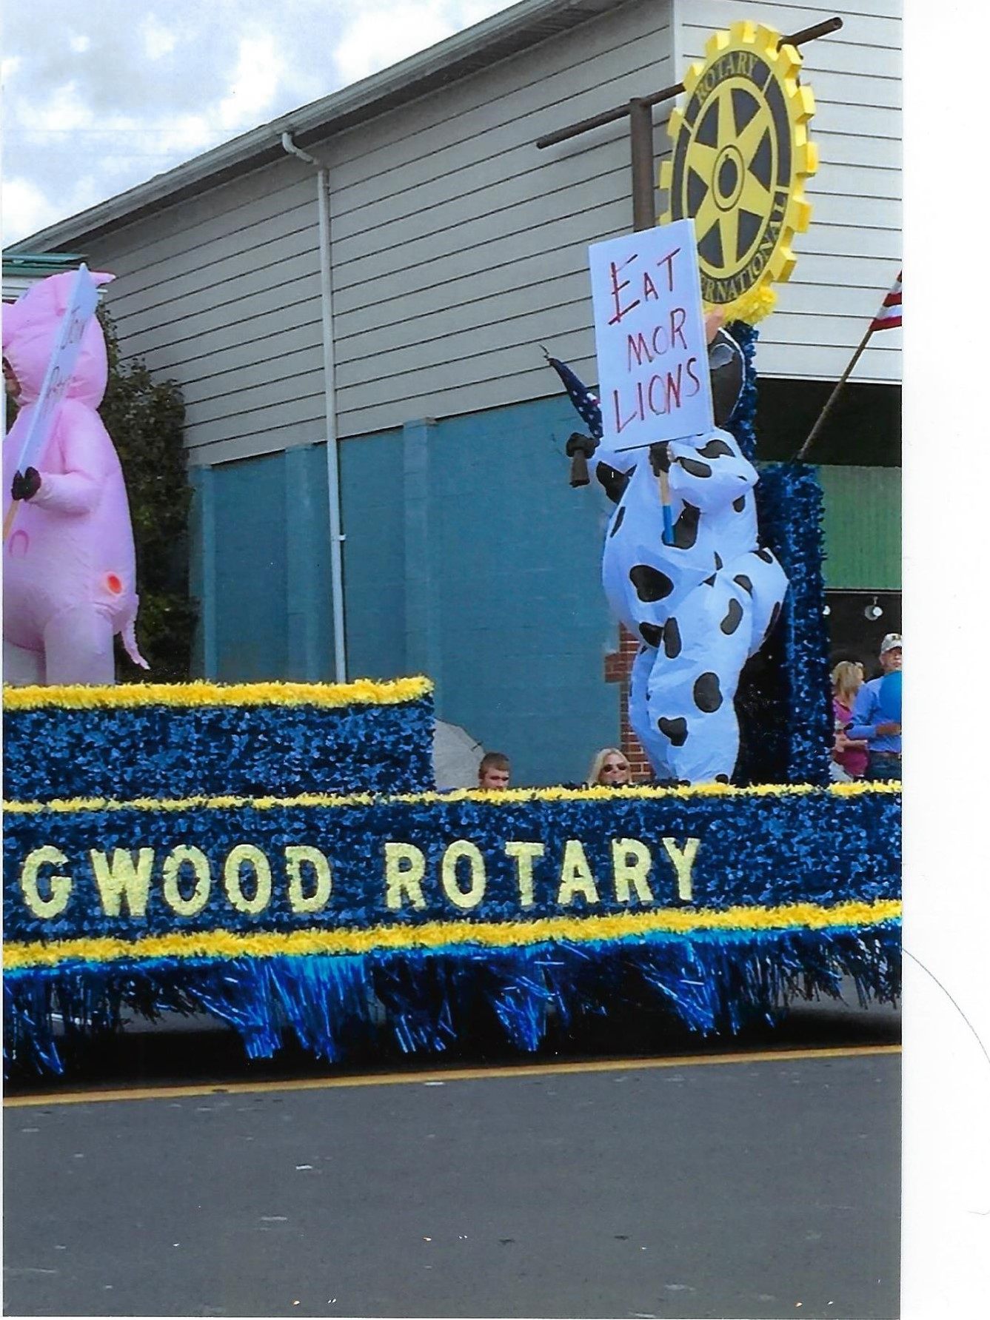
Submitted by Bob Meissner, President, Rotary Club of Kingwood

Plan to Attend and Bring Your Families For a Fun Time!

District 7530 Conference, May 3-5, 2019
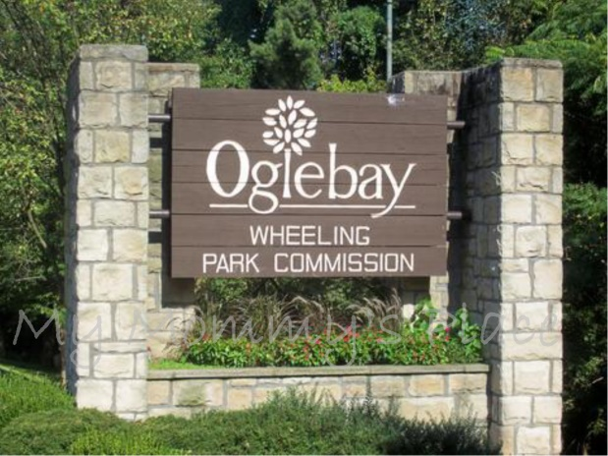
At Oglebay Park, Wheeling West Va

“I had NO IDEA how much Rotary did until I came to Conference” – feedback from 2018 delegate
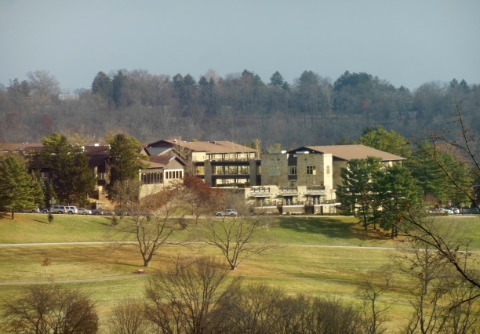
Whether you’re a long time Rotarian, a newbie or a partner who wonders what it’s all about, come and find out for yourself. We’ve listened to members’ feedback and we’re working hard to make it a weekend to remember – inspiring speakers, lots of interaction, opportunities to learn from each other and have some fun. Come away with ideas and practical support to take action and create lasting change in our communities at home and around the globe.

Planned Events:
- Our Rotary club presentations
- Exceptional speakers
- House of Friendship
- Use of Oglebay Park facilities
- Rise Against Hunger food packaging
- Golf tournament
- Fun!

Mark your calendars. Registration info coming soon!
The Rotary Club of Morgantown
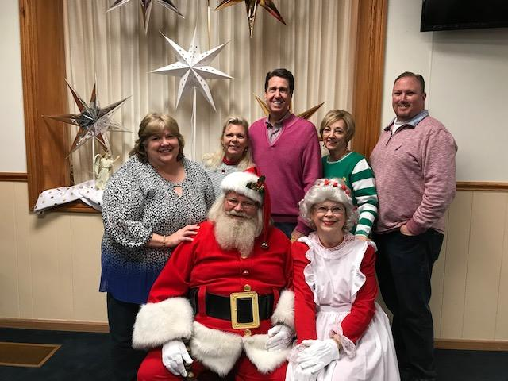

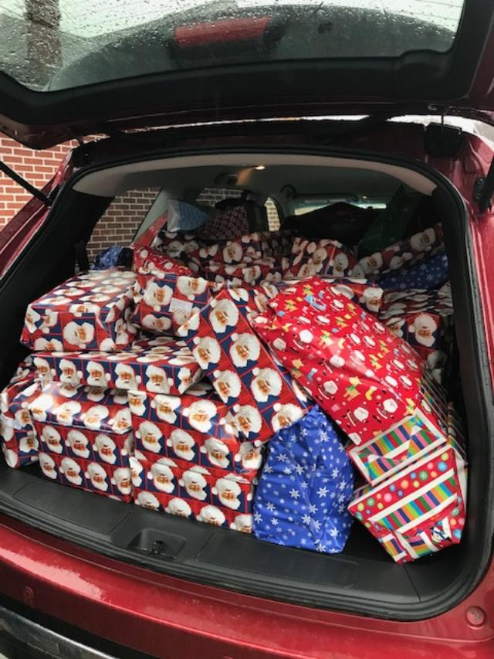
The Rotary Club of Morgantown provided gifts for 50 of the Area of Foster Children from the National Youth Advocate Center. The families enjoyed dinner, crafts and then Mr. and Mrs. Clause showed up to help distribute all the gifts. Many children are removed from their homes with only the clothes they are wearing, so being able to see them smile when they get a gift from Santa is very rewarding. Rotarian’s donated over $3,000.00 to use for the party.

The

