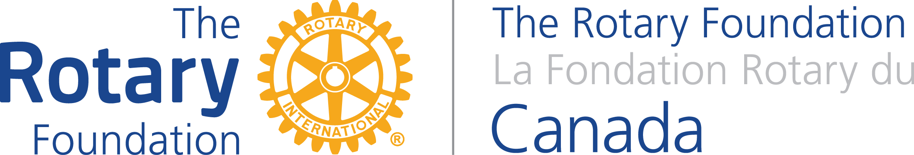

The Partnership for Community Development
Environmental Sustainability Assessment
For Global Grant Projects Applying for Funds under the Canadian Department of Foreign Affairs, Trade & Development

- Are you constructing, expanding, operating, or demolishing any human-made structure that has a fixed location or will your project directly lead to any of these things (e.g. buildings, roads, latrines, wells or water-supply systems, ponds, mines, etc.)?

YES | NO

If yes, please contact TRFC immediately as your project may be required to report under the Canadian Environmental Assessment Act and your project may be ineligible for funding.

- Briefly describe the physical environment in the area of your proposed project (e.g. relevant terrain, climate, water availability, soil quality, land use, resource use, important ecological or cultural features, etc.)
Please type here. The box will expand as you type.

- What potential effects could your project have on the physical environment (negative and positive, immediate and long-term effects)?

  - Could your project lead to another project that may have an impact on the environment (positive or negative)? (e.g. financing for a small business that will lead to construction of a physical structure). If yes, describe the impact this incidental project may have on the environment.

- What category under DFATD’s Environmental Integration Process do you believe your project to fall under? See the list here and in the appendix to the guidelines of this assessment.
Category B
Category C

Important Note: If you believe your project falls under Category C, ensure that your answers above justify this decision. No further action is required and you do not have to continue with completing questions 5 to 9. If your project falls under Category B please complete all the remaining questions below. The Partnership for Community Development will not fund projects that fall under Category A or D.

- What measures will you integrate into your project to:
  - mitigate/minimize any negative effects on the environment?

  - enhance positive environmental effects?

  - address potential effects of the environment on the project (e.g. reducing vulnerability to natural disasters, adapting to climate change)?

- What are the potential concerns of the public relevant to the environmental effects of your project, and how will these be addressed?

- What are the host country’s environmental policy and legal requirements relevant to your project, and how will these be addressed?

- What experience and resources does the host country or implementing organization(s) have to manage environmental effects associated with this project?

- Once the planned measures identified in question 5 have been implemented, will there be any remaining negative environmental effects? If yes, describe the impacts and how you plan to manage them.

