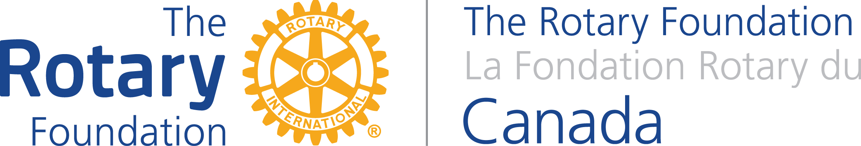

The Partnership for Community Development
Governance Template
For Global Grant Projects Applying for Funds under the Canadian Department of Foreign Affairs, Trade & Development

- Does this project support the most vulnerable and marginalized populations?
Please type here. The boxes will expand as necessary as you type.

- Does this project contribute to poverty reduction?

- Does this project take into account the perspectives of the poor?

- Does this project promote democracy and international human rights standards?

- Are the results of this project sustainable?

- Has this project been informed by national priorities and/or consultations with beneficiaries?

- Are there potential negative unintended consequences related to governance that may arise as a result of this project?

- How will this project integrate good governance?

