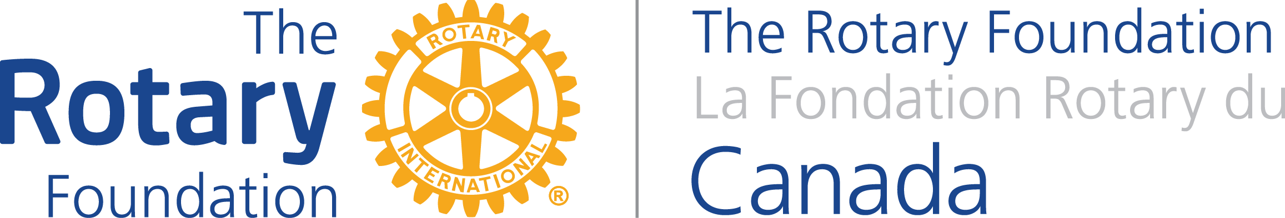

PARTNERSHIP FOR COMMUNITY DEVELOPMENT

PRE-QUALIFICATION APPLICATION EXPLANATION
PURPOSE:
The purpose of this application form is to provide The Rotary Foundation Canada (TRFC) with sufficient information that the TRFC Program Committee can determine and advise the proponents if the proposed Global Grant project will meet the additional qualification requirements and come within the scope of the agreement for Government of Canada funding support.
PROCESS:
Please begin the process for applying for a Global Grant using the Global Grant on-line application by submitting the initial information to obtain a Global Grant Number. Then if you are seeking financial support from this program please submit the Pre-qualification Application to TRFC.
The TRFC Program Committee will review the information provided and advise the proponents accordingly. Upon receipt of a positive response the project proponents may proceed to submit a Global Grant application to The Rotary Foundation (TRF) and include in that application the amount of Government of Canada funds as preliminarily approved by the TRFC program committee. Please note that the Global Grant application will be subject to the regular review and approval processes of both TRF and TRFC.
PROJECT ELIGIBILITY:
This program has been designed to as much as possible enable Canadian Rotary Clubs and Districts to access Government of Canada (GoC) funds for projects designed to meet the criteria of The Rotary Foundation’s Global Grant program. However, the focus of the GoC development assistance is somewhat more narrowly focused than the Global Grant program and the list of eligible countries may differ, as do some of the restrictions. As both the Global Grant and GoC initiatives are dynamic, please review the eligibility of both programs before proceeding. Global grant eligibility information will be found on the RI website and the GoC eligibility criterion will be found on the TRFC website.
The GoC has three key development assistance objectives: gender equity; environmental sustainability; and good governance that all projects under this program must address. The assessment of the current state of those three elements in the project’s host community must be completed and submitted as part of the pre-qualification process.
IMPORTANT!
How to submit your request:
To submit your pre-qualification project form – email it to grantstrfc@gmail.com with the following title in the subject header consisting of your GG number, name of country where project will be done and the sponsoring club name. For example: GG 1234567, Nepal, Cortes RC
All your correspondence to TRF Canada should be identified in the same manner.

INFORMATION OR CLARIFICATION:
For more program information go to the TRFC website: http://portal.clubrunner.ca/100984/Stories/program-info
Should you require clarification of the requirements or process, please forward inquiries to TRFC via email at: grantstrfc@gmail.com

